Test Plan

|  |  |  |  |
| --- | --- | --- | --- |
| Type of Testing | Approach | Use Case | Schedule |
| Unit Testing | White Box | Sign Up | 29/09/2017  - 05/10/2017 |
| Unit Testing | White Box | Record New Training Session | 29/09/2017  - 05/10/2017 |
| Unit Testing | White Box | Register for Training | 05/10/2017  - 09/10/2017 |
| Unit Testing | White Box | View Training History | 05/10/2017  - 09/10/2017 |
| Integration Testing | Black Box, Top down approach | Sign Up | 10/10/2017  -15/10/2017 |
| Integration Testing | Black Box, Top down approach | Record New Training Session | 10/10/2017  -15/10/2017 |
| Integration Testing | Black Box, Top down approach | Record New Training Session | 10/10/2017  -15/10/2017 |
| Integration Testing | Black Box, Top down approach | View Training History | 10/10/2017  -15/10/2017 |
| System Testing (Functional Testing) | Black Box | Sign Up | 16/10/2017  -23/10/2017 |
| System Testing (Functional Testing) | Black Box | Record New Training Session | 16/10/2017  -23/10/2017 |
| System Testing (Functional Testing) | Black Box | Register for Training | 16/10/2017  -23/10/2017 |
| System Testing (Functional Testing) | Black Box | View Training History | 16/10/2017  -23/10/2017 |
| Security Test | Black Box | Access Login, Access to all pages from Member and Trainer | 16/10/2017  -23/10/2017 |
| Timing Test | Black Box | Sign Up, Record New Training Session, Register For Training Session, and View Training History | 16/10/2017  -23/10/2017 |
| Compatibility Test | Black Box | Sign Up, Record New Training Session, Register for Training Session and View History | 16/10/2017  -23/10/2017 |
| Data Integrity Test | Black Box | Sign Up and Record New Training Session | 16/10/2017  -23/10/2017 |

Volume test

For (int i; i<5000; i++){

Insert into

}

Test Result

Unit Testing for Use case 1 Sign Up

Test Case 1: Login

|  |  |
| --- | --- |
| Input | Username = “”  Password “” |
| Source Code | <div class="col-xs-10 col-xs-offset-1" >  <input type="text" name="username" class="form-control  input-lg" id="inputName" placeholder="UserName" required>  </div> |
| Expected Outcome | Error message display “Please fill this field”, shown on the Username textbox |
| Actual Outcome | Error message display “Please fill this field” |

Test Case 2: Login

|  |  |
| --- | --- |
| Input | Username = “Wong”  Password “” |
| Source Code | <div class="col-xs-10 col-xs-offset-1">  <input type="password" name="password" class="form-control  input-lg checked " id="inputName" placeholder="Password"  required>  </div> |
| Expected Outcome | Error message display “Please fill this field”, shown on the Password textbox |
| Actual Outcome | “Please fill this field”, |

Test Case 3: Login

|  |  |
| --- | --- |
| Input | Username = “Wong”  Password “123456” |
| Source Code | $result = $conn->query("SELECT * FROM users WHERE userName='$username' and password='$password'");  while($rs = $result->fetch_array())  {  $_SESSION['checkLogin'] = 1;  $_SESSION['user_ID'] = $rs["userID"];  $_SESSION['userFullName'] = $rs["fullName"];  $_SESSION['user_Name'] = $rs['userName'];  $_SESSION['user_Email'] = $rs['email'];  $_SESSION['user_Password'] =  $rs['password'];  $_SESSION['user_Type'] = $rs['userType'];  }  if ($_SESSION['user_Name'] == $username &&  $_SESSION['user_Password'] == $password) {  if ($_SESSION['user_Type'] == 1) {  echo "<script>  window.location.assign(  'trainer_homepage.php');  </script>";  } else{  echo "<script>  window.location.assign(  'member_homepage.php');  </script>";  }  }else{  echo '<script language = "javascript">';  echo 'alert("Username and Password are not  found.")';  echo '</script>';  echo "<script> window.location.assign('  login_page.php'); </script>";  } |
| Expected Outcome | Error message display for either wrong password or username “Username and Password are not found”, shown on the Username textbox. |
| Actual Outcome | “Username and Password are not found” |

Test Case 4: Login

|  |  |
| --- | --- |
| Input | Username = “Kvin”  Password “123456”  Or Username =”Rahimi”  Password =”123456” |
| Source Code | $result = $conn->query("SELECT * FROM users WHERE userName='$username' and password='$password'");  while($rs = $result->fetch_array())  {  $_SESSION['checkLogin'] = 1;  $_SESSION['user_ID'] = $rs["userID"];  $_SESSION['userFullName'] = $rs["fullName"];  $_SESSION['user_Name'] = $rs['userName'];  $_SESSION['user_Email'] = $rs['email'];  $_SESSION['user_Password'] =  $rs['password'];  $_SESSION['user_Type'] = $rs['userType'];  }  if ($_SESSION['user_Name'] == $username &&  $_SESSION['user_Password'] == $password) {  if ($_SESSION['user_Type'] == 1) {  echo "<script> window.location.assign('trainer_homepage.php');  </script>";  } else{  echo "<script>  window.location.assign('member_homepage.php');  </script>";  }  }else{  echo '<script language =  "javascript">';  echo 'alert("Username and Password  are not found.")';  echo '</script>';  echo "<script>  window.location.assign(  'login_page.php'); </script>";  } |
| Expected Outcome | Member or Trainer homepage will be directed to the user if the email or password is correct. |
| Actual Outcome | Member or Trainer homepage will be directed to the user |

Test Case 5: Forgot Password

|  |  |
| --- | --- |
| Input | Email=”” |
| Source Code | <div class="col-xs-10 col-xs-offset-1" >  <input type="email" name="email" class="form-control input-  lg" id="inputName" placeholder="Email Address" required>  </div> |
| Expected Outcome | Error message display “Please fill this field”, shown on the Username textbox |
| Actual Outcome | “Please fill this field”, |

Test Case 6: Forgot Password

|  |  |
| --- | --- |
| Input | Email=”wkvin@gmail.com” |
| Source Code | <div class="col-xs-10 col-xs-offset-1" >  <input type="email" name="email" class="form-control input-  lg" id="inputName" placeholder="Email Address" required>  </div> |
| Expected Outcome | Error message display “Please fill this field”, shown on the Username textbox |
| Actual Outcome | “Please fill this field”, |

Test Case 7: Forgot Password

|  |  |
| --- | --- |
| Input | Email=”wkvin@gmail.com” |
| Source Code | $checkEmail = mysqli_query($conn,"SELECT email FROM users where email ='$email'");  $row = mysqli_fetch_array($checkEmail);  $data = $row[0];  if($data){  $sql1 = "SELECT fullName,password FROM users where  email = '$email'";  $result = $conn->query($sql1);  while ($rst = $result->fetch_array()) {  $hisFullName = $rst['fullName'];  $hisPasswor = $rst['password'];  }    echo '<script language = "javascript">';  echo 'alert("You have already sign Up!!")';  echo '</script>';  echo "<script>  window.location.assign('login_page.php'); </script>";  emailTo($email,$hisFullName,$hisPasswor);  }else{  echo '<script language =  "javascript">';  echo 'alert("This email doesn\'t  exist in the Database!!")';  echo '</script>';  echo "<script>  window.location.assign  ('forgotpassword.php'); </script>";  } |
| Expected Outcome | If wrong email address entered. Error message display “This email doesn\'t exist in the Database!!" |
| Actual Outcome | “This email doesn\'t exist in the Database!!" |

Test Case 8: Forgot Password

|  |  |
| --- | --- |
| Input | Email=”kvin@gmail.com” |
| Source Code | $checkEmail = mysqli_query($conn,"SELECT email FROM users where email ='$email'");  $row = mysqli_fetch_array($checkEmail);  $data = $row[0];  if($data){  $sql1 = "SELECT fullName,password FROM users where  email = '$email'";  $result = $conn->query($sql1);  while ($rst = $result->fetch_array()) {  $hisFullName = $rst['fullName'];  $hisPasswor = $rst['password'];  }    echo '<script language = "javascript">';  echo 'alert("The reset email is sent to your email, please check on your email!!")';  echo '</script>';  echo "<script>  window.location.assign('login_page.php'); </script>";  emailTo($email,$hisFullName,$hisPasswor);  } |
| Expected Outcome | Successful message, “The reset email is sent to your email, please check on your email!!” , login page will be directed. Email sent to user’s email address. |
| Actual Outcome | “The reset email is sent to your email, please check on your email!!” , login page will be directed. Email sent to user’s email address. |

Test Case 9: Sign Up (Member)

|  |  |
| --- | --- |
| Input | Username = “”  Full Name = “”  Email address = “”  Password = “”  Confirm Password = “”  Address = “”  Level = “” |
| Source Code | if( document.member_signup.fullname.value == "" && document.member_signup.username.value == ""  && document.member_signup.emailadd.value == "" && document.member_signup.password.value ==""  && document.member_signup.confirmpass.value =="" && document.member_signup.address.value == ""  && document.getElementsByName('level')[0].value == "level"){  alert( "Please ensure all fields are filled!" );  //stop submission action  e.preventDefault();  } |
| Expected Outcome | Error message display “Please ensure all fields are filled!”, shown on top of the website and all textboxes will have red color border |
| Actual Outcome | “Please ensure all fields are filled!” and all textboxes will have red color border |

Test Case 10: Sign Up (Member)

|  |  |
| --- | --- |
| Input | Username = “wkvin”  Full Name = “1234”  Email address = “”  Password = “”  Confirm Password = “”  Address = “”  Level = “” |
| Source Code | //To validate if user is enter with alphabets value/  function validateStringInput(){  //Declare variable to only accept string/  var alphaExp = /^[a-zA-Z]+$/;  if(document.member_signup.fullname.value.match(alphaExp)){  document.getElementById("fullname").style.border="1px solid green";  }else{  alert('Please enter only alphabets!');  document.member_signup.fullname.focus() ;  document.getElementById("fullname").style.border="1px solid red";  document.getElementById("fullname").addEventListener("click", function(event){  event.preventDefault()  }); |
| Expected Outcome | Error message display “'Please enter only alphabets” and red color border on Fullname textbox |
| Actual Outcome | “'Please enter only alphabets!” and red color border on Fullname textbox |

Test Case 11: Sign Up (Member)

|  |  |
| --- | --- |
| Input | Username = “Kvin”  Full Name = “wkvin”  Email address = “k”  Password = “”  Confirm Password = “”  Address = “”  Level = “” |
| Source Code | function validateEmail(){  //Declare variable that only accept an email format inout/  var reg = /^([A-Za-z0-9_\-\.])+\@([A-Za-z0-9_\-\.])+\.([A-Za-z]{2,4})$/;  if (reg.test(document.member_signup.emailadd.value) == false){  alert('Invalid Email Address');  document.member_signup.emailadd.focus() ;  //using id of the textbox and give them styling/  document.getElementById("emailadd").style.border="1px solid red";  document.getElementById("myAnchor").addEventListener("click", function(event){  event.preventDefault()  });} |
| Expected Outcome | Error message display “Invalid Email Address!” and red color border at email textbox |
| Actual Outcome | Invalid Email Address!” and red color border at email textbox |

Test Case 12: Sign Up (Member)

|  |  |
| --- | --- |
| Input | Username = “kevin”  Full Name = “wkvin”  Email address = “kvin@gmail.com”  Password = “123456”  Confirm Password = “123456”  Address = “jalan sentosa 554”  Level = “Beginner” |
| Source Code | $checkEmail = mysqli_query($conn,"SELECT email FROM user where email ='$email'");  $row = mysqli_fetch_array($checkEmail);  $data = $row[0];  if($data){  echo '<script language = "javascript">';  echo 'alert("You have already sign Up!!")';  echo '</script>';  echo "<script> window.location.assign('login_page.php'); </script>";  } |
| Expected Outcome | Error message display “You have already sign Up!!” if email is in the database already |
| Actual Outcome | “You have already sign Up!!” |

Test Case 13: Sign Up (Member)

|  |  |
| --- | --- |
| Input | Username = “kevin”  Full Name = “wkvin”  Email address = “kvin@gmail.com”  Password = “123456”  Confirm Password = “123456”  Address = “jalan sentosa 554”  Level = “Beginner”  j |
| Source Code | if(password.value.length > 5){  password.style.backgroundColor = success;  }  else{  alert( "Please enter at least 6 digit!");  document.member_signup.fullname.focus() ;  document.getElementById("password").style.border="1px solid red";  password.style.backgroundColor = error;  document.getElementById("password").addEventListener("click", function(event){  event.preventDefault()  }); |
| Expected Outcome | Error message display "Please enter at least 6 digit!” and red color border on Password textbox |
| Actual Outcome | "Please enter at least 6 digit!” and red color border on Password textbox |

Test Case 14: Sign Up (Member)

|  |  |
| --- | --- |
| Input | Username = “wkvin”  Full Name = “wkvin”  Email address = “k@gmail.com”  Password = “123456”  Confirm Password = “”  Address = “”  Level = “” |
| Source Code | if(pass1.value == pass2.value){  //The passwords match.  //Set the color to the good color and inform  //the user that they have entered the correct password  pass2.style.backgroundColor = success;  }else{  //The passwords do not match.  //Set the color to the bad color and  //notify the user.  pass2.style.backgroundColor = error;  alert("Passwords Do Not Match!");  document.getElementById("confirmpass").addEventListener("click", function(event){  event.preventDefault() |
| Expected Outcome | Error message display and red color border on Password textbox |
| Actual Outcome | " Passwords Do Not Match” and red color border on Password textbox |

Test Case 15: Sign Up (Member)

|  |  |
| --- | --- |
| Input | Username = “wkvin”  Full Name = “wkvin”  Email address = “k@gmail.com”  Password = “123456”  Confirm Password = “1234567”  Address = “”  Level = “” |
| Source Code | if(pass1.value == pass2.value){  //The passwords match.  //Set the color to the good color and inform  //the user that they have entered the correct password  pass2.style.backgroundColor = success;  }else{  //The passwords do not match.  //Set the color to the bad color and  //notify the user.  pass2.style.backgroundColor = error;  alert("Passwords Do Not Match!");  document.getElementById("confirmpass").addEventListener("click", function(event){  event.preventDefault() |
| Expected Outcome | Error message display " Passwords Do Not Match” and red color border on Password textbox |
| Actual Outcome | " Passwords Do Not Match” and red color border on Password textbox |

Test Case 16: Sign Up (Member)

|  |  |
| --- | --- |
| Input | Username = “kevin”  Full Name = “wkvin”  Email address = “wwkvin@gmail.com”  Password = “12345”  Confirm Password = “12345”  Address = “jalan sentosa 54”  Level = “Beginner” |
| Source Code | var add = document.getElementById('address');  //Compare the values in the password field  //and the confirmation field  if(add.value.length > 5){  document.getElementById("address").style.border="1px solid green";  }  else{  alert( "Please enter at least 6 digit!");  document.member_signup.address.focus() ;  document.getElementById("address").style.border="1px solid red";  document.getElementById("address").addEventListener("click", function(event){  event.preventDefault()  }); |
| Expected Outcome | Error message display "Please enter at least 6 digit!"and red color border on Password textbox |
| Actual Outcome | "Please enter at least 6 digit!"and red color border on Address textbox |

Test Case 17: Sign Up (Member)

|  |  |
| --- | --- |
| Input | Username = “wkvin”  Full Name = “wkvin”  Email address = “k@gmail.com”  Password = “123456”  Confirm Password = “123456”  Address = “jalan sentosa 54”  Level = “” |
| Source Code | if ( document.getElementsByName('level')[0].value == "level" ){    document.getElementById("level").style.border="1px solid red";  e.preventDefault();  } |
| Expected Outcome | red color border on Level dropdown box |
| Actual Outcome | red color border on Level dropdown box |

Test Case 18: Sign Up (Member)

|  |  |
| --- | --- |
| Input | Username = “wkvin”  Full Name = “wkvin”  Email address = “k@gmail.com”  Password = “123456”  Confirm Password = “123456”  Address = “jalan sentosa 54”  Level = “Beginner” |
| Source Code | $sql = "INSERT INTO member (fullName, userName, password, email, level, address) VALUES ('$fullName','$userName','$password','$email', '$level','$address')";  if ($conn->query($sql) == TRUE && mysqli_affected_rows($conn) >0){  echo '<script language = "javascript">';  echo 'alert("Record Added successfully")';  echo '</script>';  echo "<script> window.location.assign('homepage.php'); </script>";  } |
| Expected Outcome | Successful message will be displayed, "Record Added successfully" and member homepage will be directed |
| Actual Outcome | "Record Added successfully" and member homepage will be directed |

Test Case 18: Sign Up (Trainer)

|  |  |
| --- | --- |
| Input | Username = “rahimiD”  Full Name = “Rahimi Diallo”  Email address = “rd@gmail.com”  Password = “123456”  Confirm Password = “123456”  Address = “jalan semantan 2”  Specialty = “” |
| Source Code | if( document.trainer_signup.Speciality.value == ""){  document.trainer_signup.Speciality.focus() ;  document.getElementById("Speciality").style.border="1px solid red";  e.preventDefault();  }else{  document.getElementById("Speciality").style.border="1px solid green";  } |
| Expected Outcome | Red color border on specialty Specialty textbox |
| Actual Outcome | Red color border on specialty Specialty textbox |

Unit Testing for Use case 2 Record New Training Session

Test Case 1: Login

|  |  |
| --- | --- |
| Input | Username = “Rahimi”  Password “” |
| Source Code | <div class="col-xs-10 col-xs-offset-1">  <input type="password" name="password" class="form-control  input-lg checked " id="inputName" placeholder="Password"  required>  </div> |
| Expected Outcome | Error message display “Please fill this field”, shown on the Password textbox |
| Actual Outcome | “Please fill this field”, |

Test Case 2: Login

|  |  |
| --- | --- |
| Input | Username = “Rahimi”  Password “123456” |
| Source Code | $result = $conn->query("SELECT * FROM users WHERE userName='$username' and password='$password'");  while($rs = $result->fetch_array())  {  $_SESSION['checkLogin'] = 1;  $_SESSION['user_ID'] = $rs["userID"];  $_SESSION['userFullName'] = $rs["fullName"];  $_SESSION['user_Name'] = $rs['userName'];  $_SESSION['user_Email'] = $rs['email'];  $_SESSION['user_Password'] = $rs['password'];  $_SESSION['user_Type'] = $rs['userType'];  }  if ($_SESSION['user_Type'] == 1) {  echo '<script language = "javascript">';  echo "alert('Welcome!')";  echo '</script>';  echo "<script>  window.location.assign('trainer_homepage.php');  </script>";  } |
| Expected Outcome | Sucessful message displayed “Welcome!”, Trainer homepage will be directed |
| Actual Outcome | “Welcome!”, Trainer homepage will be directed |

Test Case 3: Record a Training Session (Personal)

|  |  |
| --- | --- |
| Input | Title = “”  Date = “”  Time = “”  Fee = “” |
| Source Code | if (!empty($title)&&!empty($date)&&!empty($time)&&!empty($fee)&&!empty($type)&&!empty($traineID)) {  $sql = "INSERT INTO trainingsession (titel, date, time, feee, notes,sessionType ,classType, maxParticipants, trainerID) VALUES ('$title','$date','$time','$fee','$notes','$sessionType', '$type','$maxParticipants','$traineID')";  if ($conn->query($sql) == TRUE && mysqli_affected_rows($conn) >0){  echo '<script language = "javascript">';  echo 'alert("Record Added successfully")';  echo '</script>';  echo "<script> window.location.assign('trainer_session_personal.php'); </script>";  }  else  {  echo " Error Adding record: ".$conn->error;  }  }else{  echo '<script language = "javascript">';  echo 'alert("All the field most be completed")';  echo '</script>';  echo "<script> window.location.assign('trainer_session_personal.php'); </script>";  } |
| Expected Outcome | Error message displayed “All the field most be completed!” |
| Actual Outcome | “All the field most be completed!” |

Test Case 4: Record a Training Session (Personal)

|  |  |
| --- | --- |
| Input | Title = “Samba Class”  Date = “”  Time = “”  Fee = “” |
| Source Code | if (!empty($title)&&!empty($date)&&!empty($time)&&!empty($fee)&&!empty($type)&&!empty($traineID)) {  $sql = "INSERT INTO trainingsession (titel, date, time, feee, notes,sessionType ,classType, maxParticipants, trainerID) VALUES ('$title','$date','$time','$fee','$notes','$sessionType', '$type','$maxParticipants','$traineID')";  if ($conn->query($sql) == TRUE && mysqli_affected_rows($conn) >0){  echo '<script language = "javascript">';  echo 'alert("Record Added successfully")';  echo '</script>';  echo "<script> window.location.assign('trainer_session_personal.php'); </script>";  }  else  {  echo " Error Adding record: ".$conn->error;  }  }else{  echo '<script language = "javascript">';  echo 'alert("All the field most be completed")';  echo '</script>';  echo "<script> window.location.assign('trainer_session_personal.php'); </script>";  } |
| Expected Outcome | Error message displayed “All the field most be completed!” |
| Actual Outcome | “All the field most be completed!” |

Test Case 5: Record a Training Session (Personal)

|  |  |
| --- | --- |
| Input | Title = “Samba Class”  Date = “12 October2017”  Time = “10:20AM”  Fee = “” |
| Source Code | if (!empty($title)&&!empty($date)&&!empty($time)&&!empty($fee)&&!empty($type)&&!empty($traineID)) {  $sql = "INSERT INTO trainingsession (titel, date, time, feee, notes,sessionType ,classType, maxParticipants, trainerID) VALUES ('$title','$date','$time','$fee','$notes','$sessionType', '$type','$maxParticipants','$traineID')";  if ($conn->query($sql) == TRUE && mysqli_affected_rows($conn) >0){  echo '<script language = "javascript">';  echo 'alert("Record Added successfully")';  echo '</script>';  echo "<script> window.location.assign('trainer_session_personal.php'); </script>";  }  else  {  echo " Error Adding record: ".$conn->error;  }  }else{  echo '<script language = "javascript">';  echo 'alert("All the field most be completed")';  echo '</script>';  echo "<script> window.location.assign('trainer_session_personal.php'); </script>";  } |
| Expected Outcome | Error message displayed “All the field most be completed!” |
| Actual Outcome | “All the field most be completed!” |

Test Case 6: Record a Training Session (Personal)

|  |  |
| --- | --- |
| Input | Title = “Samba Class”  Date = “12 October2017”  Time = “10:20AM”  Fee = “a” |
| Source Code | if(is_numeric($fee)){  $sql = "INSERT INTO trainingsession (titel, date, time, feee, notes,sessionType ,classType, maxParticipants, trainerID) VALUES ('$title','$date','$time','$fee','$notes','$sessionType', '$type','$maxParticipants','$traineID')";  if ($conn->query($sql) == TRUE && mysqli_affected_rows($conn) >0){  echo '<script language = "javascript">';  echo 'alert("Record Added successfully")';  echo '</script>';  echo "<script> window.location.assign('trainer_session_personal.php'); </script>";  }  else  {  echo " Error Adding record: ".$conn->error;  }  } else{  echo '<script language = "javascript">';  echo 'alert("Fee must be in numeric format!")';  echo '</script>';  echo "<script> window.location.assign('trainer_session_personal.php'); </script>";  } |
| Expected Outcome | Error message displayed “Fee must be in numeric format!” |
| Actual Outcome | “Fee must be in numeric format!” |

Test Case 7: Record a Training Session (Personal)

|  |  |
| --- | --- |
| Input | Title = “Samba Class”  Date = “25 October2017”  Time = “10:20AM”  Fee = “100” |
| Source Code | if (!empty($title)&&!empty($date)&&!empty($time)&&!empty($fee)&&!empty($type)&&!empty($traineID)) {  $sql = "INSERT INTO trainingsession (titel, date, time, feee, notes,sessionType ,classType, maxParticipants, trainerID) VALUES ('$title','$date','$time','$fee','$notes','$sessionType', '$type','$maxParticipants','$traineID')";  if ($conn->query($sql) == TRUE && mysqli_affected_rows($conn) >0){  echo '<script language = "javascript">';  echo 'alert("Record Added successfully")';  echo '</script>';  echo "<script> window.location.assign('trainer_session_personal.php'); </script>";  }  else  {  echo " Error Adding record: ".$conn->error;  }  }else{  echo '<script language = "javascript">';  echo 'alert("All the field most be completed")';  echo '</script>';  echo "<script> window.location.assign('trainer_session_personal.php'); </script>";  } |
| Expected Outcome | Success message displayed “Record Added successfully |
| Actual Outcome | “Record Added successfully” |

Test Case 8: Record a Training Session (Personal)

|  |  |
| --- | --- |
| Input | Title = “Samba Advance”  Date = “1 November 2017”1  Time = 12:00PM”  Fee = “300”  MySQL Database is off in Xampp application |
| Source Code | if (!empty($title)&&!empty($date)&&!empty($time)&&!empty($fee)&&!empty($type)&&!empty($traineID)) {  $sql = "INSERT INTO trainingsession (titel, date, time, feee, notes,sessionType ,classType, maxParticipants, trainerID) VALUES ('$title','$date','$time','$fee','$notes','$sessionType', '$type','$maxParticipants','$traineID')";  if ($conn->query($sql) == TRUE && mysqli_affected_rows($conn) >0){  echo '<script language = "javascript">';  echo 'alert("Record Added successfully")';  echo '</script>';  echo "<script> window.location.assign('trainer_session_personal.php'); </script>";  }  else  {  echo " Error Adding record: ".$conn->error;  }  }else{  echo '<script language = "javascript">';  echo 'alert("All the field most be completed")';  echo '</script>';  echo "<script> window.location.assign('trainer_session_personal.php'); </script>";  } |
| Expected Outcome | 1 **Warning**: mysqli_connect(): (HY000/2002): No such file or directory in **/Applications/XAMPP/xamppfiles/htdocs/BIT210 v3.5/Bit210/addPrSession.php** on line **21**  **Notice**: Trying to get property of non-object in **/Applications/XAMPP/xamppfiles/htdocs/BIT210 v3.5/Bit210/addPrSession.php** on line **23**  **Fatal error**: Call to a member function query() on boolean in **/Applications/XAMPP/xamppfiles/htdocs/BIT210 v3.5/Bit210/addPrSession.php** on line **34** |
| Actual Outcome | 1 **Warning**: mysqli_connect(): (HY000/2002): No such file or directory in **/Applications/XAMPP/xamppfiles/htdocs/BIT210 v3.5/Bit210/addPrSession.php** on line **21**  **Notice**: Trying to get property of non-object in **/Applications/XAMPP/xamppfiles/htdocs/BIT210 v3.5/Bit210/addPrSession.php** on line **23**  **Fatal error**: Call to a member function query() on boolean in **/Applications/XAMPP/xamppfiles/htdocs/BIT210 v3.5/Bit210/addPrSession.php** on line **34** |

Test case 9: Record a Training Session (Group)

|  |  |
| --- | --- |
| Input | Title = “”  Date = “”  Time = “”  Fee = “”  Max = “”  Type =”” |
| Source Code | if (!empty($title)&&!empty($date)&&!empty($time)&&!empty($fee)&&!empty($type)&&!empty($traineID)) {  $sql = "INSERT INTO trainingsession (titel, date, time, feee, notes,sessionType ,classType, maxParticipants, trainerID) VALUES ('$title','$date','$time','$fee','$notes','$sessionType', '$type','$maxParticipants','$traineID')";  if ($conn->query($sql) == TRUE && mysqli_affected_rows($conn) >0){  echo '<script language = "javascript">';  echo 'alert("Record Added successfully")';  echo '</script>';  echo "<script> window.location.assign('trainer_session_personal.php'); </script>";  }  else  {  echo " Error Adding record: ".$conn->error;  }  }else{  echo '<script language = "javascript">';  echo 'alert("All the field most be completed")';  echo '</script>';  echo "<script> window.location.assign('trainer_session_personal.php'); </script>";  } |
| Expected Outcome | Error message displayed “All the field most be completed!” |
| Actual Outcome | “All the field most be completed!” |

Test case 10: Record a Training Session (Group)

|  |  |
| --- | --- |
| Input | Title = “Yoga Class”  Date = “25 October2017”  Time = “08:00PM”  Fee = “200”  Max = “”  Type =”Sport” |
| Source Code | if (!empty($title)&&!empty($date)&&!empty($time)&&!empty($fee)&&!empty($type)&&!empty($traineID)) {  $sql = "INSERT INTO trainingsession (titel, date, time, feee, notes,sessionType ,classType, maxParticipants, trainerID) VALUES ('$title','$date','$time','$fee','$notes','$sessionType', '$type','$maxParticipants','$traineID')";  if ($conn->query($sql) == TRUE && mysqli_affected_rows($conn) >0){  echo '<script language = "javascript">';  echo 'alert("Record Added successfully")';  echo '</script>';  echo "<script> window.location.assign('trainer_session_personal.php'); </script>";  }  else  {  echo " Error Adding record: ".$conn->error;  }  }else{  echo '<script language = "javascript">';  echo 'alert("All the field most be completed")';  echo '</script>';  echo "<script> window.location.assign('trainer_session_personal.php'); </script>";  } |
| Expected Outcome | Error message displayed “All the field most be completed!” |
| Actual Outcome | “All the field most be completed!” |

Test Case 11: Record a Training Session (Group)

|  |  |
| --- | --- |
| Input | Title = “Yoga Class”  Date = “25 October2017”  Time = “”  Fee = “200”  Max = “20”  Type =”Sport” |
| Source Code | if(is_numeric($fee)){  $sql = "INSERT INTO trainingsession (titel, date, time, feee, notes,sessionType ,classType, maxParticipants, trainerID) VALUES ('$title','$date','$time','$fee','$notes','$sessionType', '$type','$maxParticipants','$traineID')";  if ($conn->query($sql) == TRUE && mysqli_affected_rows($conn) >0){  echo '<script language = "javascript">';  echo 'alert("Record Added successfully")';  echo '</script>';  echo "<script> window.location.assign('trainer_session_personal.php'); </script>";  }  else  {  echo " Error Adding record: ".$conn->error;  }  } else{  echo '<script language = "javascript">';  echo 'alert("Fee must be in numeric format!")';  echo '</script>';  echo "<script> window.location.assign('trainer_session_personal.php'); </script>";  } |
| Expected Outcome | Error message displayed “All the field most be completed!” |
| Actual Outcome | “All the field most be completed!” |

Test case 12: Record a Training Session (Group)

|  |  |
| --- | --- |
| Input | Title = “Yoga Class”  Date = “25 October2017”  Time = “08:00PM”  Fee = “100”  Max = “20”  Type =”Sport” |
| Source Code | $sql = "INSERT INTO trainingsession (titel, date, time, feee, notes,sessionType ,classType, maxParticipants, trainerID) VALUES ('$title','$date','$time','$fee','$notes','$sessionType', '$type','$maxParticipants','$traineID')";  if ($conn->query($sql) == TRUE && mysqli_affected_rows($conn) >0){  echo '<script language = "javascript">';  echo 'alert("Record Added successfully")';  echo '</script>';  echo "<script> window.location.assign('trainer_session_group.php'); </script>";  } |
| Expected Outcome | Success message displayed “Record Added successfully |
| Actual Outcome | “Record Added successfully” |

Unit Testing for Use case 3 Register for Training Session

Test Case 1: Login

|  |  |
| --- | --- |
| Input | Username = “Kvin”  Password “” |
| Source Code | <div class="col-xs-10 col-xs-offset-1">  <input type="password" name="password" class="form-control  input-lg checked " id="inputName" placeholder="Password"  required>  </div> |
| Expected Outcome | Error message display “Please fill this field”, shown on the Password textbox |
| Actual Outcome | “Please fill this field”, |

Test Case 2: Login

|  |  |
| --- | --- |
| Input | Username = “Kvin”  Password “123456” |
| Source Code | $result = $conn->query("SELECT * FROM users WHERE userName='$username' and password='$password'");  if ($_SESSION['user_Type'] == 1) {    echo '<script language = "javascript">';  echo "alert('Welcome!')";  echo '</script>';  echo "<script> window.location.assign('trainer_homepage.php'); </script>";  } else{  echo '<script language = "javascript">';  echo "alert('Welcome!')";  echo '</script>';  echo "<script> window.location.assign('member_homepage.php'); </script>";  } |
| Expected Outcome | Sucessful message displayed “Welcome!”, Member homepage will be directed |
| Actual Outcome | “Welcome!”, Member homepage will be directed |

Test Case 3: Register for a Trainning Session (Personal)

|  |  |
| --- | --- |
| Input | Click on the register button on the table |
| Source Code | $checkEmail = mysqli_query($conn,"SELECT memberID, sessionID FROM registredtraining where sessionID ='$sessionID' and memberID = '$memberID'");  $row = mysqli_fetch_array($checkEmail);  $data = $row[0];  if($data){  echo '<script language = "javascript">';  echo 'alert("You have already registered for this session!!")';  echo '</script>';  echo "<script> window.location.assign('member_register_session_personal.php'); </script>";  }else{  $sql = "INSERT INTO registredtraining (memberID, sessionID) VALUES ('$memberID','$sessionID')";  if ($conn->query($sql) == TRUE && mysqli_affected_rows($conn) >0){  echo '<script language = "javascript">';  echo 'alert("Registered successfully")';  echo '</script>';  echo "<script> window.location.assign('member_register_session_personal.php'); </script>";  } |
| Expected Outcome | If is not registered before, Sucessful message displayed “Registered successfully!” |
| Actual Outcome | “Registered successfully!” |

Test Case 4: Register for a Trainning Session (Personal)

|  |  |
| --- | --- |
| Input | Click on the register button on the table |
| Source Code | $checkEmail = mysqli_query($conn,"SELECT memberID, sessionID FROM registredtraining where sessionID ='$sessionID' and memberID = '$memberID'");  $row = mysqli_fetch_array($checkEmail);  $data = $row[0];  if($data){  echo '<script language = "javascript">';  echo 'alert("You have already registered for this session!!")';  echo '</script>';  echo "<script> window.location.assign('member_register_session_personal.php'); </script>";  }else{  $sql = "INSERT INTO registredtraining (memberID, sessionID) VALUES ('$memberID','$sessionID')";  if ($conn->query($sql) == TRUE && mysqli_affected_rows($conn) >0){  echo '<script language = "javascript">';  echo 'alert("Registered successfully")';  echo '</script>';  echo "<script> window.location.assign('member_register_session_personal.php'); </script>";  } |
| Expected Outcome | If is registered before, Error message displayed “You have already registered for this session!!” |
| Actual Outcome | “You have already registered for this session!!” |

Test Case 5: Register for a Trainning Session (Personal)

|  |  |
| --- | --- |
| Input | Click on the register button on the table |
| Source Code | $conn = mysqli_connect("localhost","root","","helpfit");  if ($conn->connect_error){  die("Connection failed: ".$conn->connect_error);  //echo "testing 1";  } |
| Expected Outcome | If is MySQL Database is not started on Xampp , Error message displayed “Warning: mysqli_connect(): (HY000/2002): No such file or directory in /Applications/XAMPP/xamppfiles/htdocs/BIT210 v2.0/Bit210/member_register_session_personal.php on line 91  Notice: Trying to get property of non-object in /Applications/XAMPP/xamppfiles/htdocs/BIT210 v2.0/Bit210/member_register_session_personal.php on line 93  Fatal error: Call to a member function query() on boolean in /Applications/XAMPP/xamppfiles/htdocs/BIT210 v2.0/Bit210/member_register_session_personal.php on line 99” |
| Actual Outcome | “Warning: mysqli_connect(): (HY000/2002): No such file or directory in /Applications/XAMPP/xamppfiles/htdocs/BIT210 v2.0/Bit210/member_register_session_personal.php on line 91  Notice: Trying to get property of non-object in /Applications/XAMPP/xamppfiles/htdocs/BIT210 v2.0/Bit210/member_register_session_personal.php on line 93  Fatal error: Call to a member function query() on boolean in /Applications/XAMPP/xamppfiles/htdocs/BIT210 v2.0/Bit210/member_register_session_personal.php on line 99” |

Test Case 6: Register for a Trainning Session (Group)

|  |  |
| --- | --- |
| Input | Click on the register button on the table |
| Source Code | $checkEmail = mysqli_query($conn,"SELECT memberID, sessionID FROM registredtraining where sessionID ='$sessionID' and memberID = '$memberID'");  $row = mysqli_fetch_array($checkEmail);  $data = $row[0];  if($data){  echo '<script language = "javascript">';  echo 'alert("You have already registered for this session!!")';  echo '</script>';  echo "<script> window.location.assign('member_register_session_personal.php'); </script>";  }else{  $sql = "INSERT INTO registredtraining (memberID, sessionID) VALUES ('$memberID','$sessionID')";  if ($conn->query($sql) == TRUE && mysqli_affected_rows($conn) >0){  echo '<script language = "javascript">';  echo 'alert("Registered successfully")';  echo '</script>';  echo "<script> window.location.assign('member_register_session_personal.php'); </script>";  } |
| Expected Outcome | If is registered before, Error message displayed “You have already registered for this session!!” |

Test Case 6: Register for a Trainning Session (Group)

|  |  |
| --- | --- |
| Input | Click on the register button on the table |
| Source Code | $checkEmail = mysqli_query($conn,"SELECT memberID, sessionID FROM registredtraining where sessionID ='$sessionID' and memberID = '$memberID'");  $row = mysqli_fetch_array($checkEmail);  $data = $row[0];  if($data){  echo '<script language = "javascript">';  echo 'alert("You have already registered for this session!!")';  echo '</script>';  echo "<script> window.location.assign('member_register_session_personal.php'); </script>";  }else{  $sql = "INSERT INTO registredtraining (memberID, sessionID) VALUES ('$memberID','$sessionID')";  if ($conn->query($sql) == TRUE && mysqli_affected_rows($conn) >0){  echo '<script language = "javascript">';  echo 'alert("Registered successfully")';  echo '</script>';  echo "<script> window.location.assign('member_register_session_personal.php'); </script>";  } |
| Expected Outcome | If is not registered before, Sucessful message displayed “Registered successfully!” |
| Actual Outcome | “Registered successfully!” |

Integration Testing for Sign Up

Test Case 1 for User -> Member (you need to do Test Case for User -> Trainer too)

|  |  |
| --- | --- |
| Input | Username = “”  Full Name = “”  Email address = “”  Password = “”  Confirm Password = “”  Joining as = “Member”  Training Level = “”  (fill in details) |
| Expected Outcome | (Talk about what happens when the user signs up on your website, e.g. click on sign up button, user is taken to sign up page, user enters details, click on sign up button.) |
| Actual Outcome | (Same as expected outcome but what actually happens.) |

Unit Testing for Use case 4 View Training History

Test Case 1: Login

|  |  |
| --- | --- |
| Input | Username = “Kvin”  Password “” |
| Source Code | <div class="col-xs-10 col-xs-offset-1">  <input type="password" name="password" class="form-control  input-lg checked " id="inputName" placeholder="Password"  required>  </div> |
| Expected Outcome | Error message display “Please fill this field”, shown on the Password textbox |
| Actual Outcome | “Please fill this field”, |

Test Case 2: Login (Member)

|  |  |
| --- | --- |
| Input | Username = “Kvin”  Password “123456” |
| Source Code | $result = $conn->query("SELECT * FROM users WHERE userName='$username' and password='$password'");  if ($_SESSION['user_Type'] == 1) {    echo '<script language = "javascript">';  echo "alert('Welcome!')";  echo '</script>';  echo "<script> window.location.assign('trainer_homepage.php'); </script>";  } else{  echo '<script language = "javascript">';  echo "alert('Welcome!')";  echo '</script>';  echo "<script> window.location.assign('member_homepage.php'); </script>";  } |
| Expected Outcome | Sucessful message displayed “Welcome!”, Member homepage will be directed |
| Actual Outcome | “Welcome!”, Member homepage will be directed |

Test Case 3: Login (Trainer)

|  |  |
| --- | --- |
| Input | Username = “Rahimi”  Password “123456” |
| Source Code | $result = $conn->query("SELECT * FROM users WHERE userName='$username' and password='$password'");  if ($_SESSION['user_Type'] == 1) {    echo '<script language = "javascript">';  echo "alert('Welcome!')";  echo '</script>';  echo "<script> window.location.assign('trainer_homepage.php'); </script>";  } else{  echo '<script language = "javascript">';  echo "alert('Welcome!')";  echo '</script>';  echo "<script> window.location.assign('member_homepage.php'); </script>";  } |
| Expected Outcome | Sucessful message displayed “Welcome!”, Trainer homepage will be directed |
| Actual Outcome | “Welcome!”, Trainer homepage will be directed |

Test Case 4: View Training History (Member)

|  |  |
| --- | --- |
| Input | If the training session is registed by the member |
| Source Code | <?php  $conn = mysqli_connect("localhost","root","","helpfit");  if ($conn->connect_error){  die("Connection failed: ".$conn->connect_error);  //echo "testing 1";  }  $member = $_SESSION['user_ID'];  $result = $conn->query("SELECT trainingsession.* FROM trainingsession INNER JOIN registredtraining ON registredtraining.sessionID = trainingsession.sessionID where registredtraining.memberID = '$member'");  foreach ($result as $key => $rs) {  ?>  <tr>  <td><?php echo $rs["titel"];?></td>  <td><?php echo $rs["date"];?></td>  <td><?php echo $rs["time"];?></td>  <td><?php echo $rs["sessionType"];?></td>  <td>  <div class="text-center">  <a href="trainer_review.php" class="btn btn-success use-name">Review</a>  </div>  </td>  </tr>  <?php |
| Expected Outcome | Table shown with the record registered by the member |
| Actual Outcome | Table shown with the record registered by the member |

Test Case 5: View Training History (Member)

|  |  |
| --- | --- |
| Input | If no training session is registered by the member |
| Source Code | <?php  $conn = mysqli_connect("localhost","root","","helpfit");  if ($conn->connect_error){  die("Connection failed: ".$conn->connect_error);  //echo "testing 1";  }  $member = $_SESSION['user_ID'];  $result = $conn->query("SELECT trainingsession.* FROM trainingsession INNER JOIN registredtraining ON registredtraining.sessionID = trainingsession.sessionID where registredtraining.memberID = '$member'");  foreach ($result as $key => $rs) {  ?>  <tr>  <td><?php echo $rs["titel"];?></td>  <td><?php echo $rs["date"];?></td>  <td><?php echo $rs["time"];?></td>  <td><?php echo $rs["sessionType"];?></td>  <td>  <div class="text-center">  <a href="trainer_review.php" class="btn btn-success use-name">Review</a>  </div>  </td>  </tr>  <?php |
| Expected Outcome | No record shown on the table |
| Actual Outcome | No record shown on the table |

Test Case 5: View Training History Personal (Trainer)

|  |  |
| --- | --- |
| Input | If no training session is created by the trainer |
| Source Code | <?php  $conn = mysqli_connect("localhost","root","","helpfit");  if ($conn->connect_error){  die("Connection failed: ".$conn->connect_error);  //echo "testing 1";  }  $type="Personal Training Session";  $result = $conn->query("SELECT * FROM trainingsession where sessionType = '$type'");  foreach ($result as $key => $rs) {  ?>  <tr>  <td class="id"><?php echo $rs["sessionID"];?></td>  <td><?php echo $rs["titel"];?></td>  <td><?php echo $rs["date"];?></td>  <td><?php echo $rs["time"];?></td>  <td><?php echo $rs["feee"];?></td>  <td><?php echo $rs["status"];?></td>  <td>  <div class="text-center">  <a href="trainer_session_personal_edit.php"class="btn btn-default"><em class="fa fa-pencil"></em></a>  </div>  </td>  </tr>  <?php  }  ?> |
| Expected Outcome | No record shown on the table |
| Actual Outcome | No record shown on the table |

Test Case 6: View Training History Personal (Trainer)

|  |  |
| --- | --- |
| Input | If the training session is added by the trainer |
| Source Code | <?php  $conn = mysqli_connect("localhost","root","","helpfit");  if ($conn->connect_error){  die("Connection failed: ".$conn->connect_error);  //echo "testing 1";  }  $type="Personal Training Session";  $result = $conn->query("SELECT * FROM trainingsession where sessionType = '$type'");  foreach ($result as $key => $rs) {  ?>  <tr>  <td class="id"><?php echo $rs["sessionID"];?></td>  <td><?php echo $rs["titel"];?></td>  <td><?php echo $rs["date"];?></td>  <td><?php echo $rs["time"];?></td>  <td><?php echo $rs["feee"];?></td>  <td><?php echo $rs["status"];?></td>  <td>  <div class="text-center">  <a href="trainer_session_personal_edit.php"class="btn btn-default"><em class="fa fa-pencil"></em></a>  </div>  </td>  </tr>  <?php  }  ?> |
| Expected Outcome | Table shown with the record added by the trainer |
| Actual Outcome | Table shown with the record added by the trainer |

Test Case 7: View Training History Group (Trainer)

|  |  |
| --- | --- |
| Input | If the training session is registered by the member |
| Source Code | <?php  $conn = mysqli_connect("localhost","root","","helpfit");  if ($conn->connect_error){  die("Connection failed: ".$conn->connect_error);  //echo "testing 1";  }  $type="Group Training Session";  $result = $conn->query("SELECT * FROM trainingsession where sessionType = '$type'");  foreach ($result as $key => $rs) {  ?>  <tr>  <td><?php echo $rs["titel"];?></td>  <td><?php echo $rs["date"];?></td>  <td><?php echo $rs["time"];?></td>  <td><?php echo $rs["feee"];?></td>  <td><?php echo $rs["status"];?></td>  <td><?php echo $rs["maxParticipants"];?></td>  <td><?php echo $rs["countPart"];?></td>  <td>  <div class="text-center">  <a href="trainer_session_group_edit.php"class="btn btn-default"><em class="fa fa-pencil"></em></a>  </div>  </td>  </tr>  <?php  }  ?> |
| Expected Outcome | Table shown with the record registered by the member |
| Actual Outcome | Table shown with the record registered by the member |

Test Case 8: View Training History Group (Trainer)

|  |  |
| --- | --- |
| Input | If no training session is created by the trainer |
| Source Code | <?php  $conn = mysqli_connect("localhost","root","","helpfit");  if ($conn->connect_error){  die("Connection failed: ".$conn->connect_error);  //echo "testing 1";  }  $trainer = $_SESSION['user_ID'];  $result = $conn->query("SELECT fullName FROM trainer where trainerID = '$trainer'");  $rs = $result->fetch_array();  ?>  <div class="userinfo-title">  <div class="userinfo-title-name">  <?php echo $rs['fullName']?>  </div>  <div class="userinfo-title-job">  Personal Trainer  </div>  </div>  </div> |
| Expected Outcome | No record shown on the table |
| Actual Outcome | No record shown on the table |

Integration Testing for Use case 1 Sign Up

Test Case 1 -> Sign up as a Member

|  |  |
| --- | --- |
| Input | Username = “wkvin”  Full Name = “wkvin”  Email address = “wkvin@gmail.com”  Password = “1234567”  Confirm Password = “1234567”  Address=”Jalan Sentosa 54”  Level = “Beginner” |
| Expected Outcome | A successful message is shown and homepage is directed |
| Actual Outcome | “Record added successfully!”, homepage is directed |

Screen capture:

Member sign up page Success message pop out

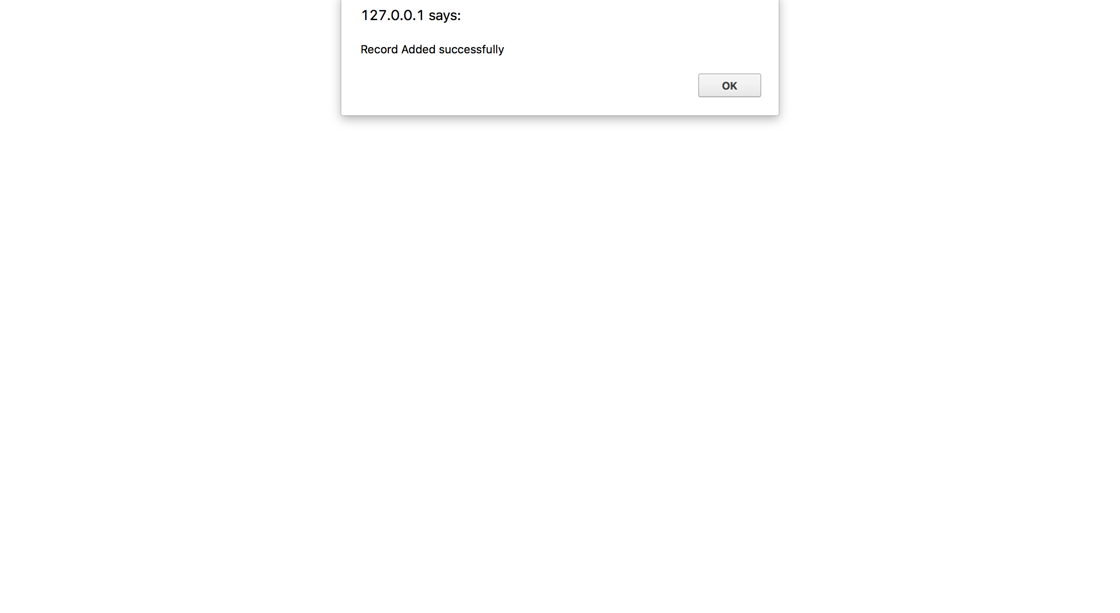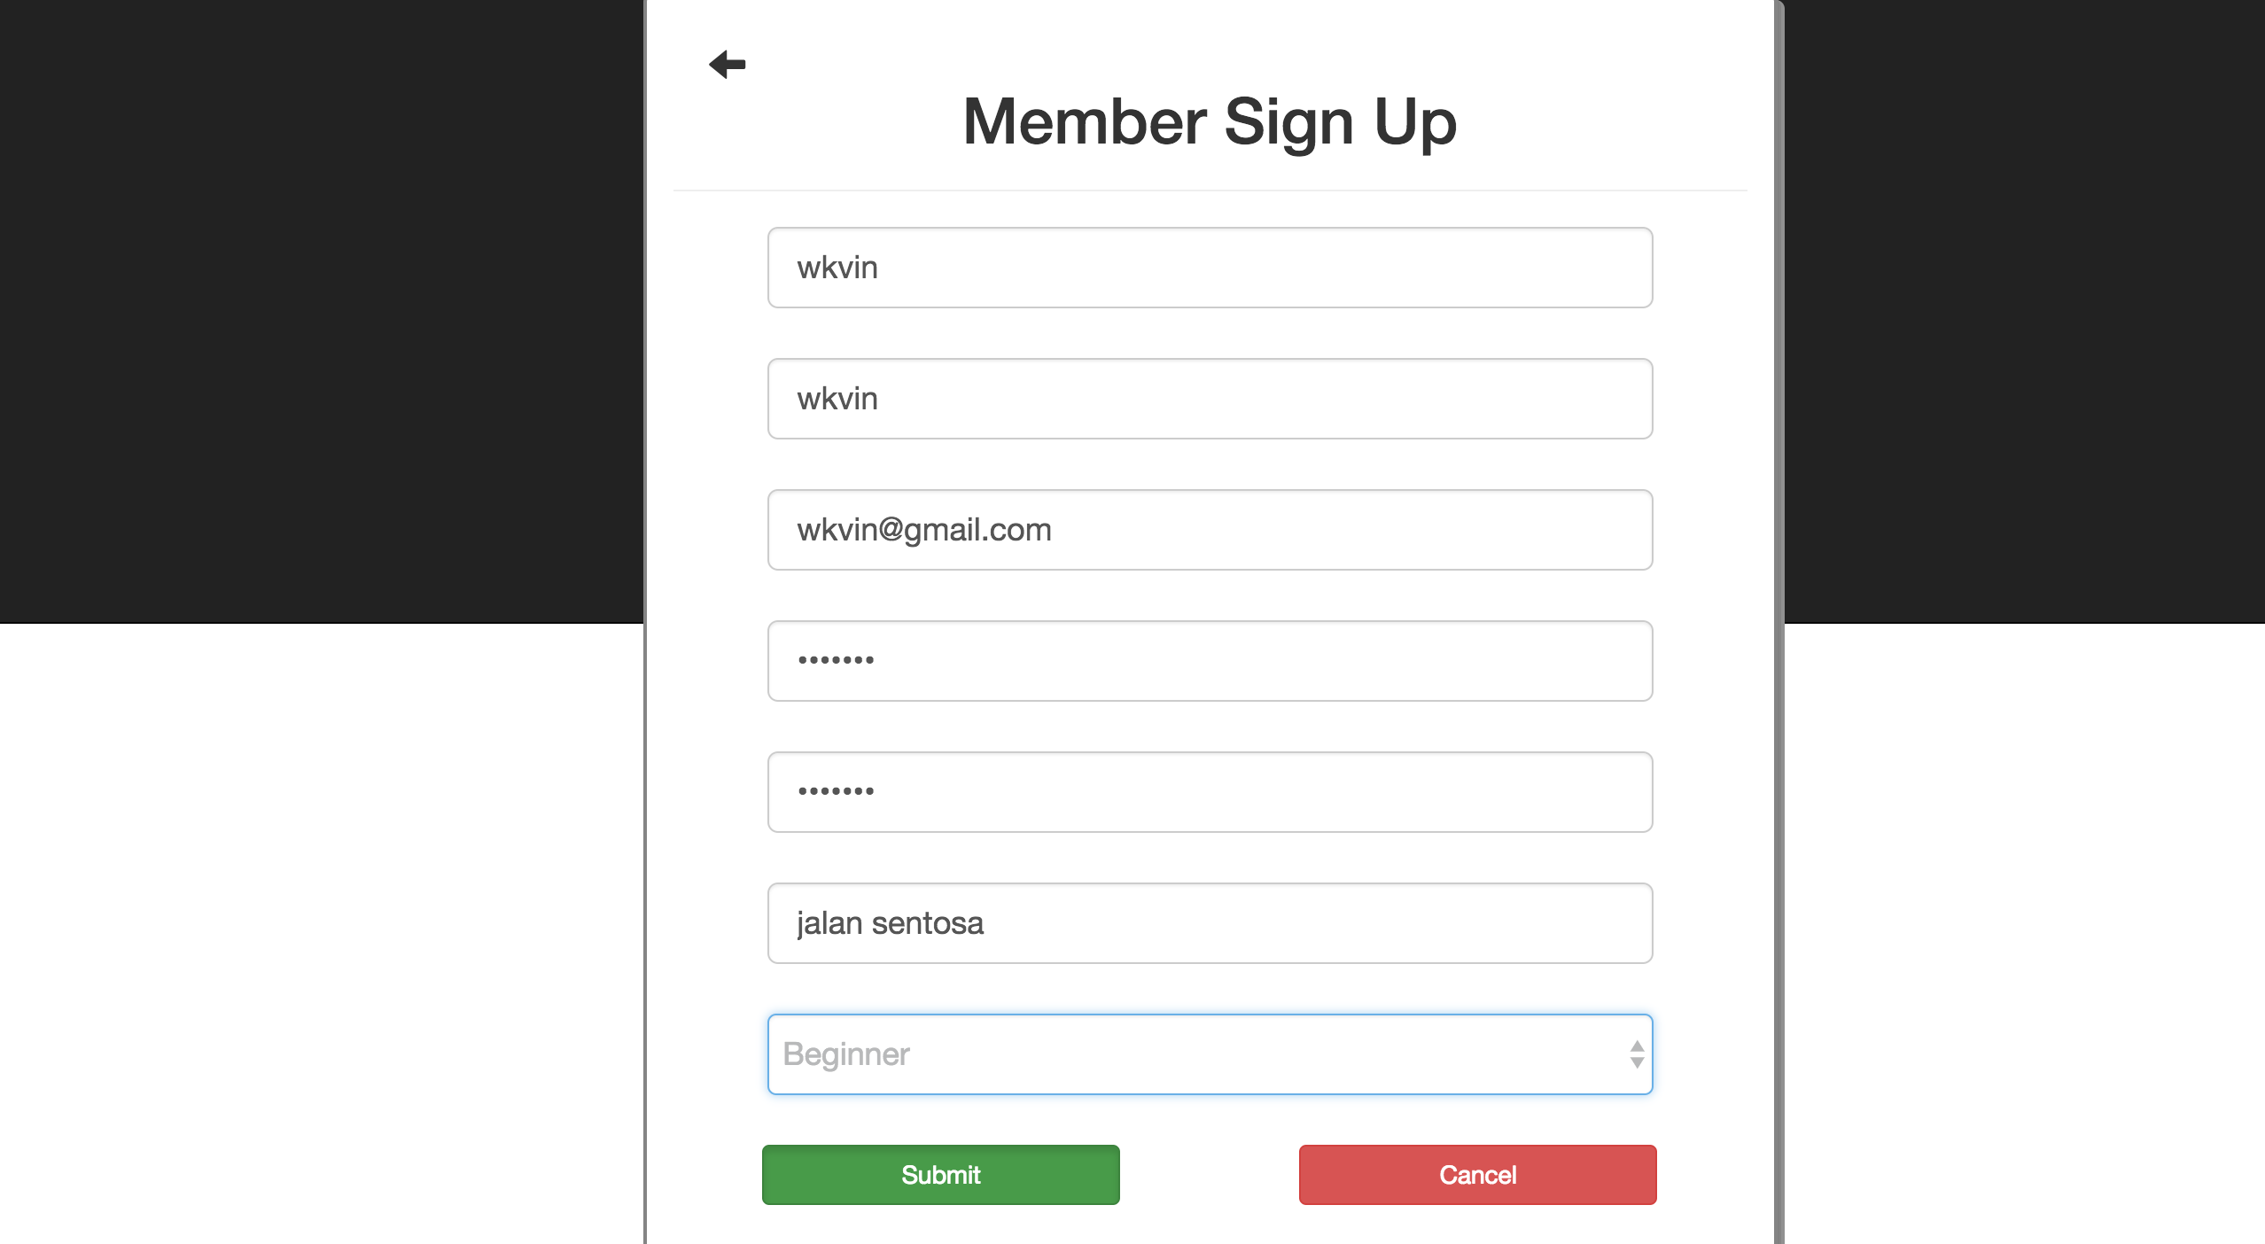 Homepage

Test Case 2 -> Login as a Member

|  |  |
| --- | --- |
| Input | Username = “wkvin”  Password = “1234567” |
| Expected Outcome | A successful message is shown and member homepage is directed |
| Actual Outcome | “Welcome!”, member homepage is directed |

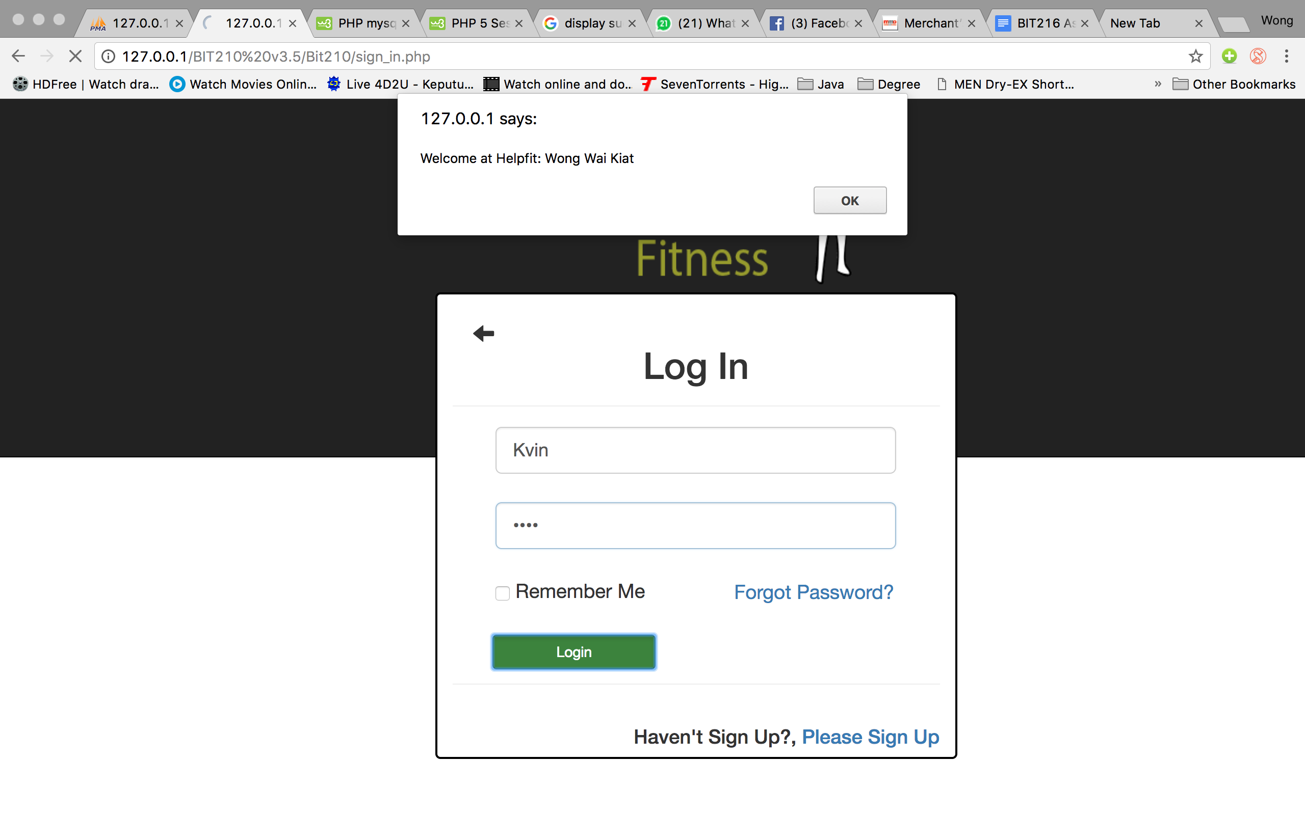Screen Capture:

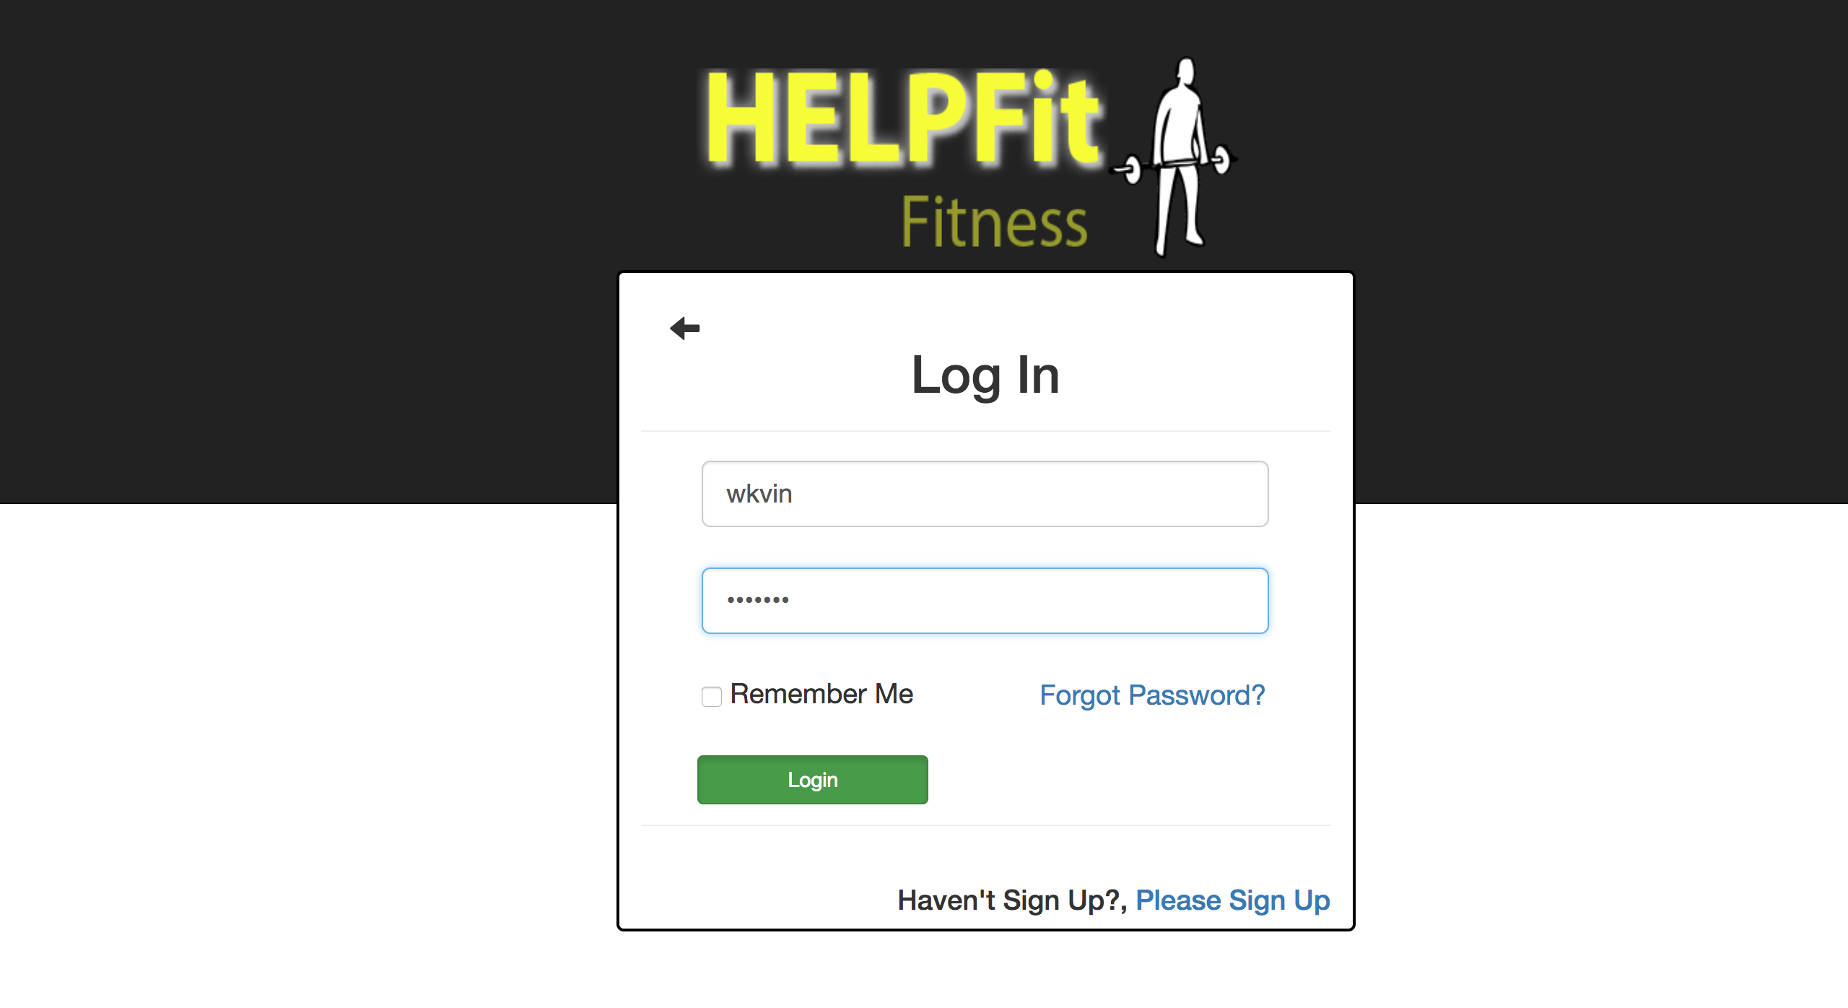Login page Success message

Pop out

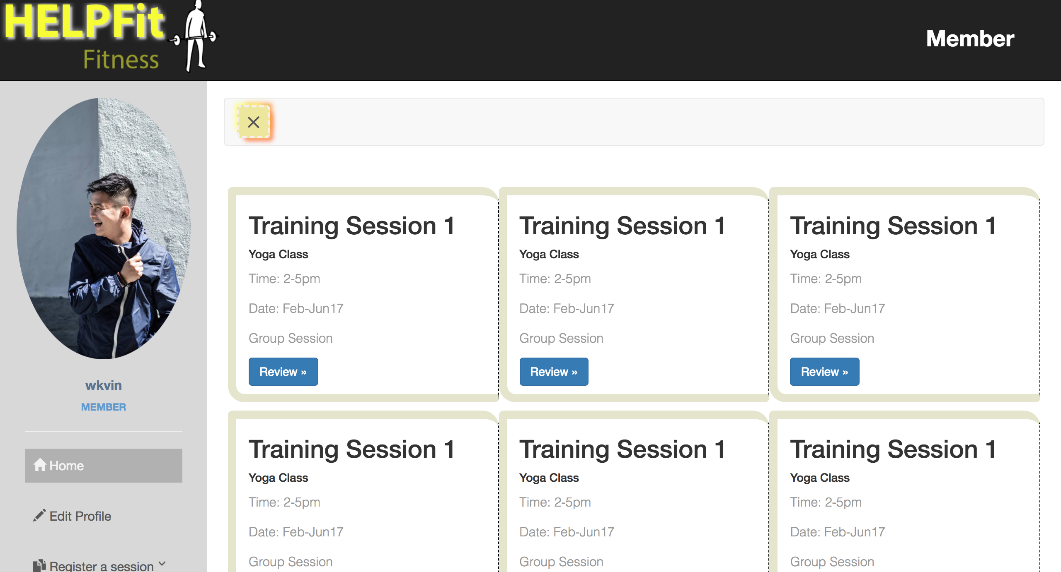 Member homepage

Test Case 3 -> Edit profile (Member)

|  |  |
| --- | --- |
| Input | Click on the sidebar edit profile |
| Expected Outcome | Edit profile page is directed |
| Actual Outcome | Edit profile page is directed |

Screen capture:

Member Hompage Member Edit Profile page

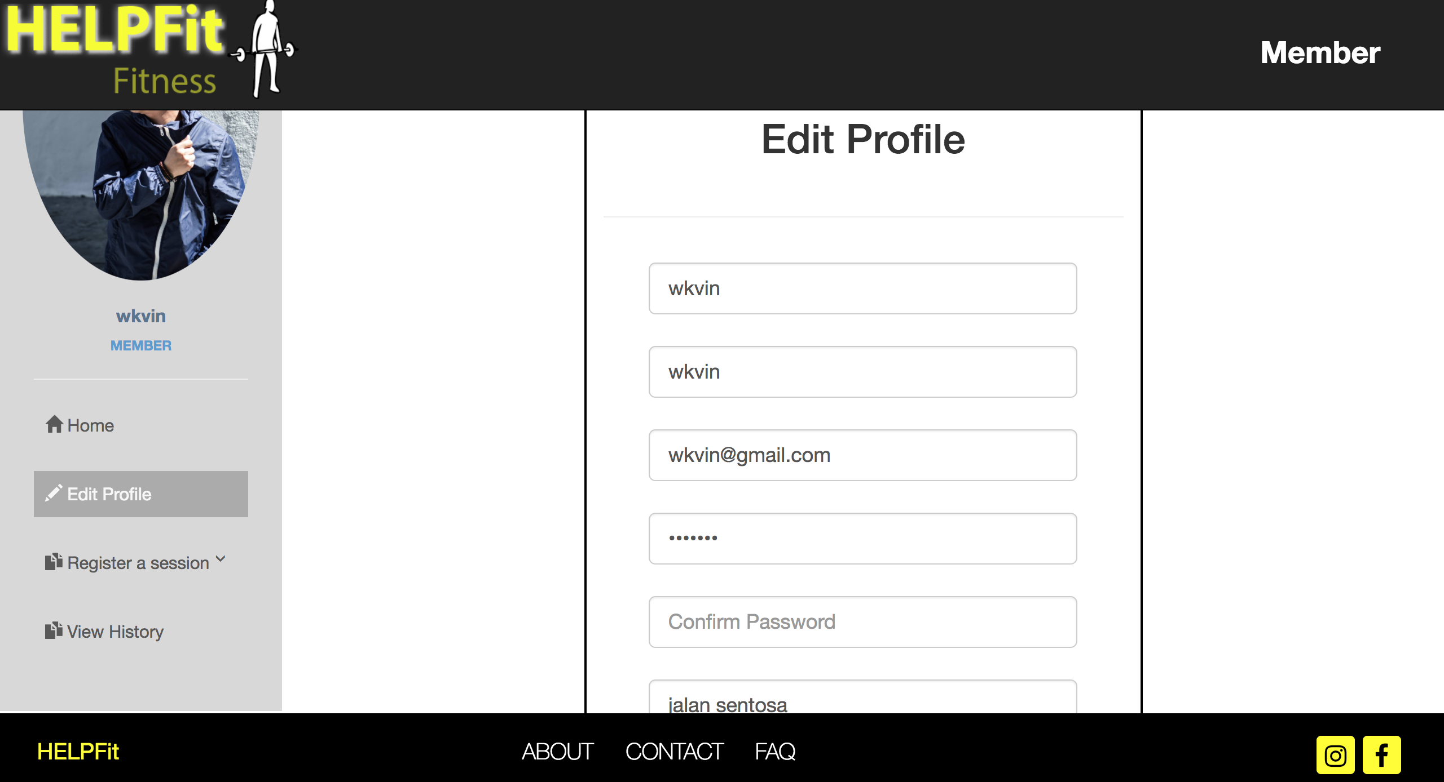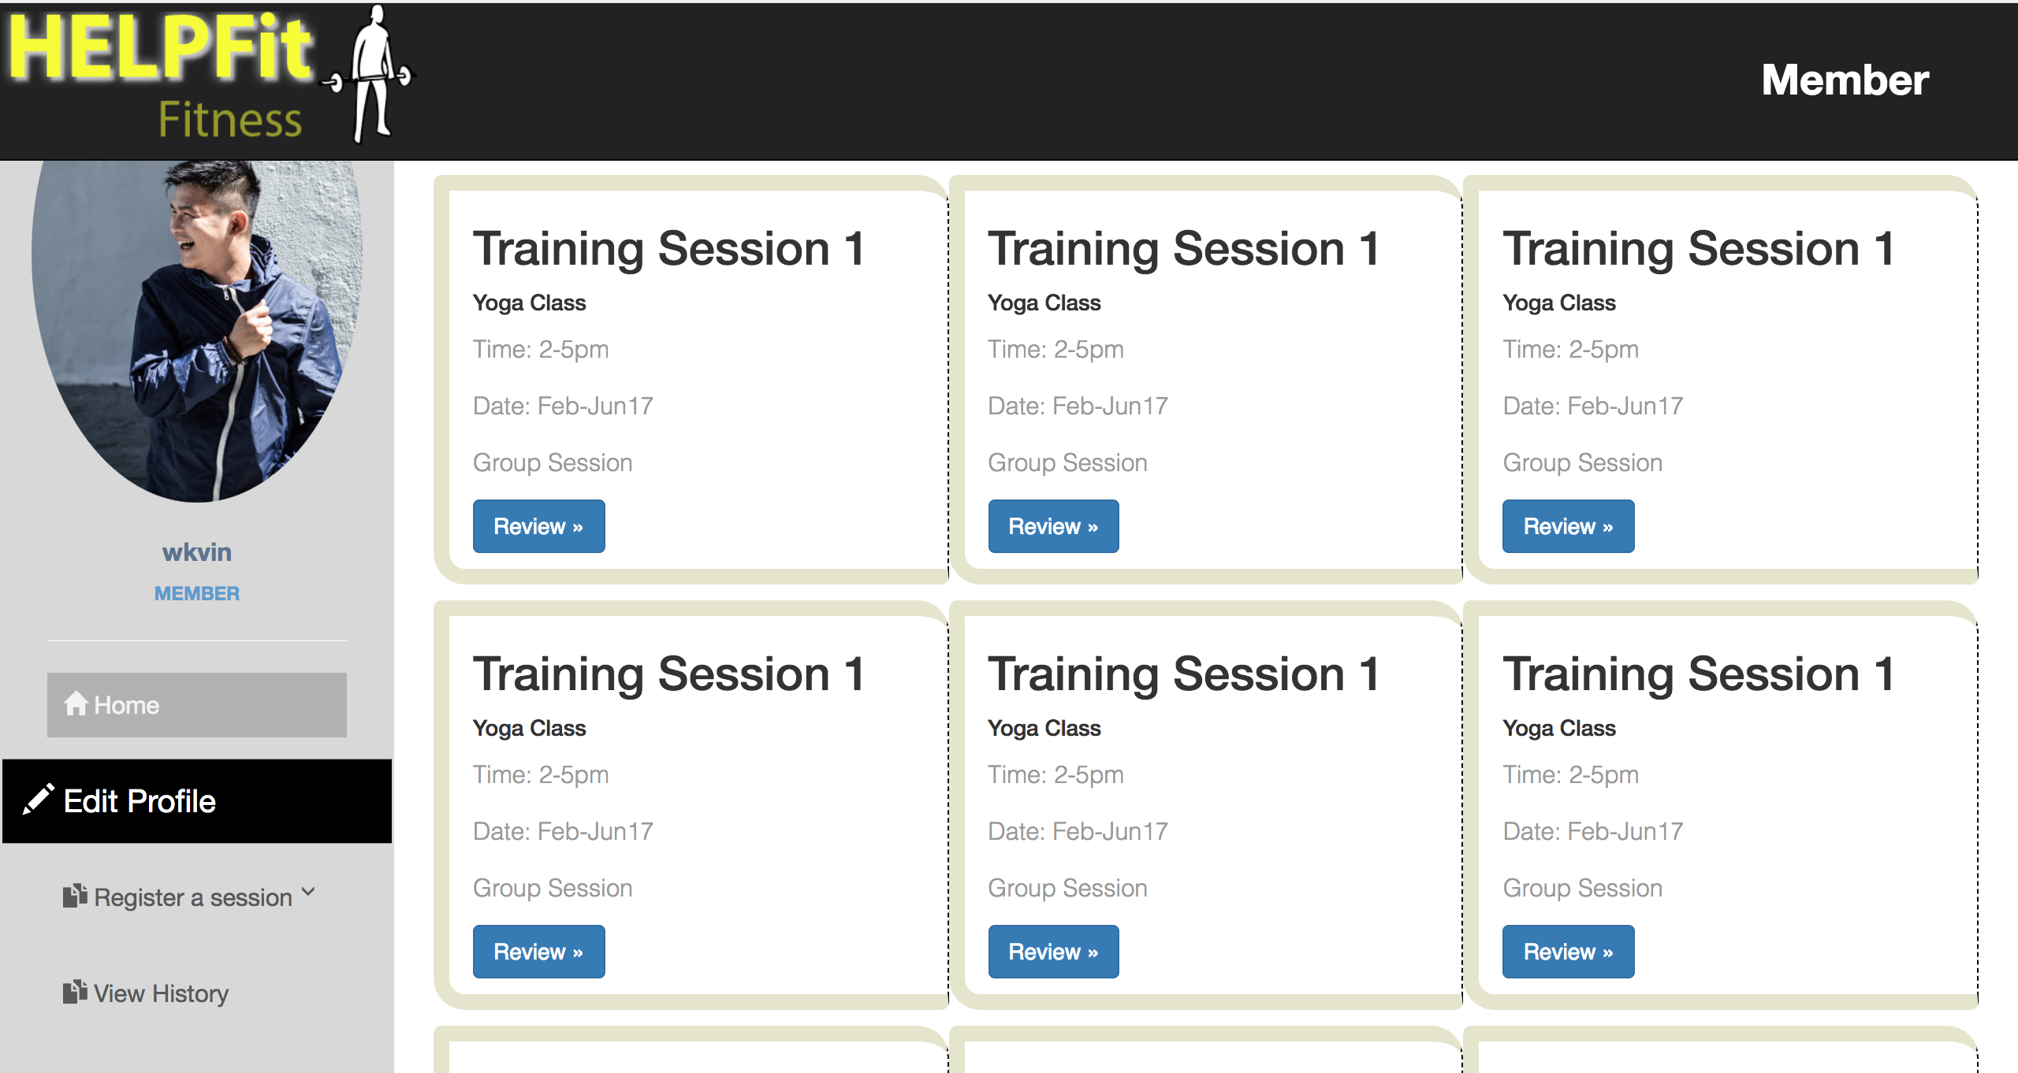

Test Case 4 -> Edit profile (Member)

|  |  |
| --- | --- |
| Input | Username = “wkvin”  Full Name = “wkvin”  Email address = “wkvin@gmail.com”  Password = “12345678”  Confirm Password = “12345678”  Address=”Jalan Sentosa 54”  Level = “Beginner” |
| Expected Outcome | A successful message is displayed, Edit profile page is directed |
| Actual Outcome | “Record edited successfully” Edit profile page is directed |

Member edit profile page Member edit profile page

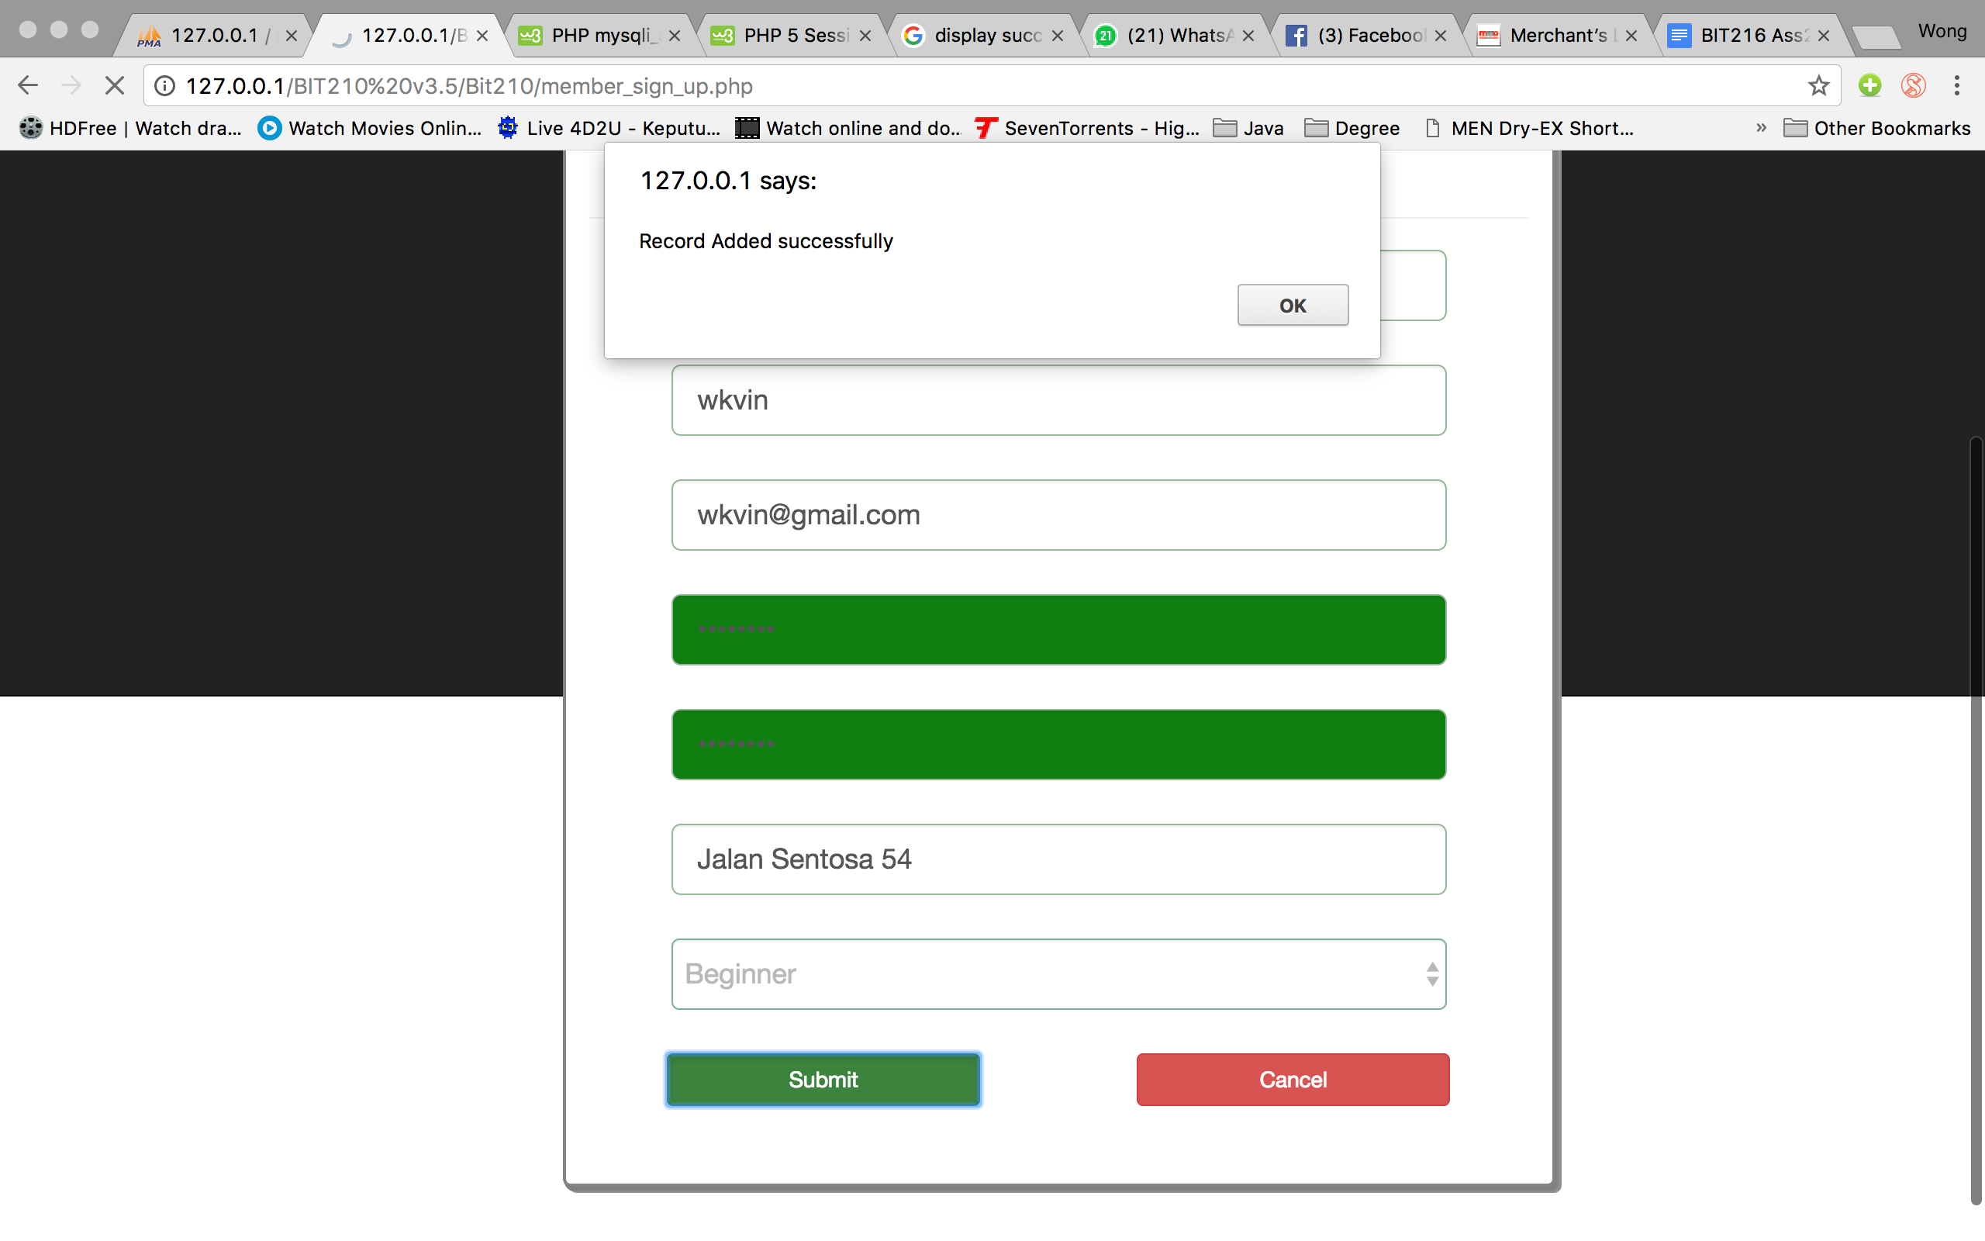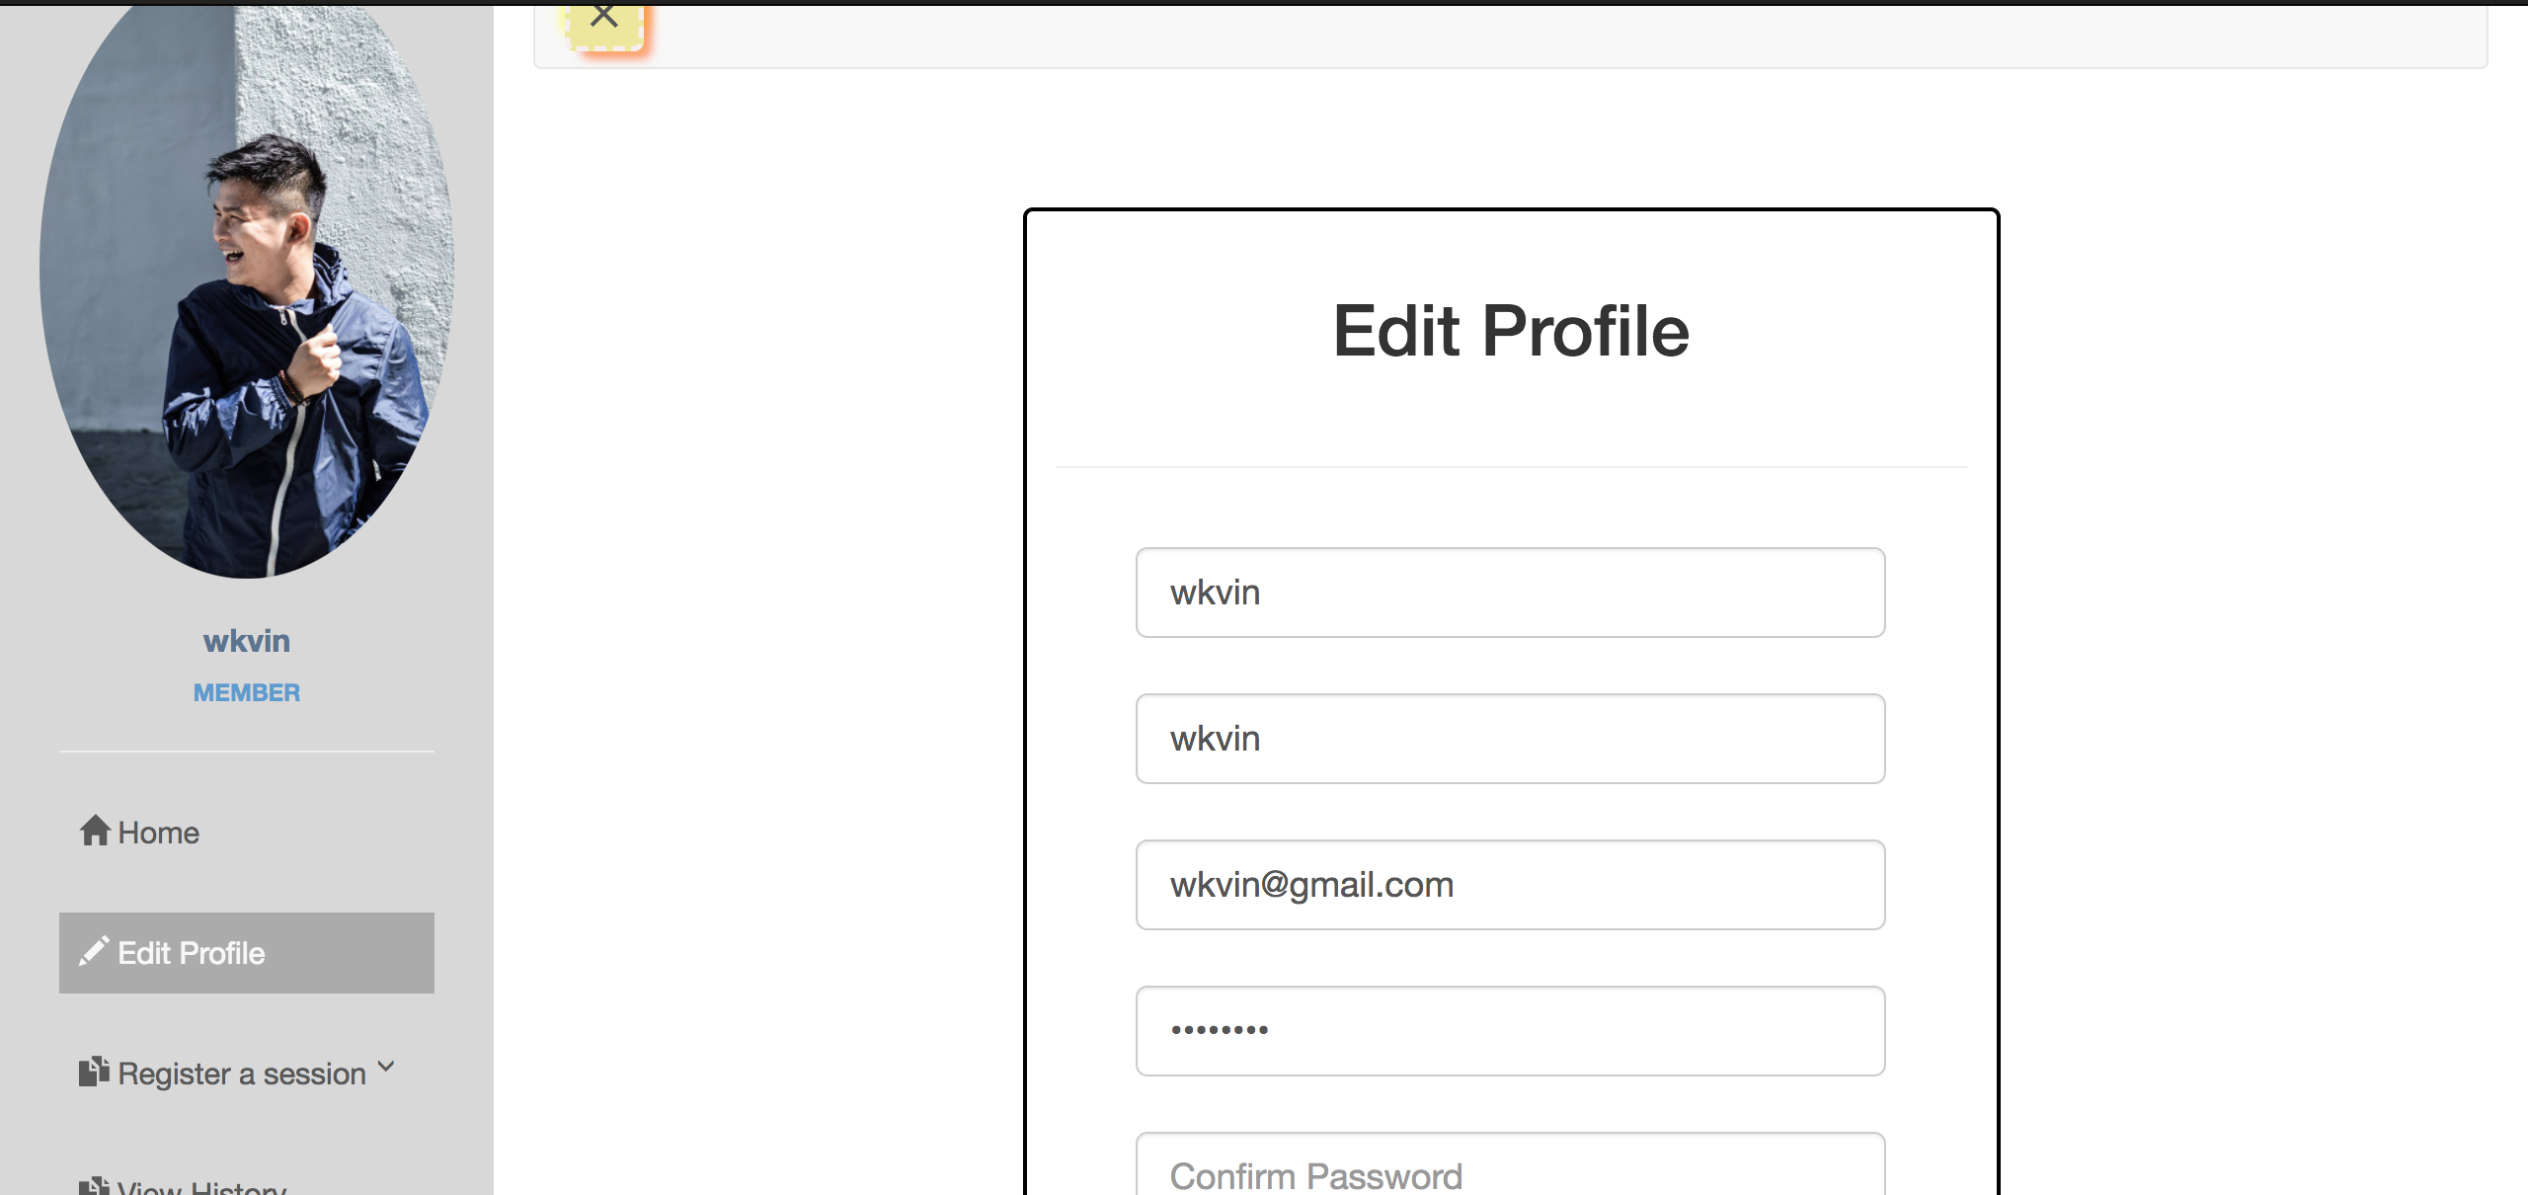

Test Case 5 -> Sign up as a Trainer

|  |  |
| --- | --- |
| Input | Username = “dan”  Full Name = “daniel”  Email address = “dan@gmail.com”  Password = “123456”  Confirm Password = “123456”  Address=”Jalan Sentosa 54”  Specialty = “Yoga Master” |
| Expected Outcome | A successful message is shown and homepage is directed |
| Actual Outcome | “Record added successfully!”, homepage is directed |

Screen Capture:

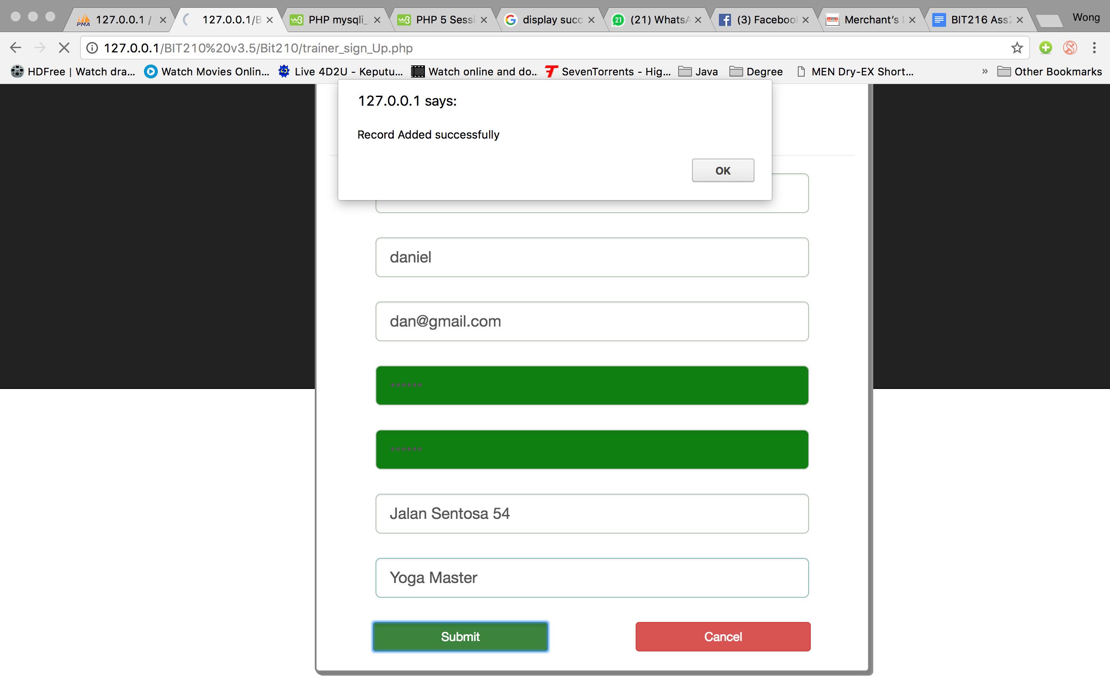Trainer edit profile page Homepage



Test Case 6 -> Login as a Trainer

|  |  |
| --- | --- |
| Input | Username = “dan”  Password = “123456” |
| Expected Outcome | A successful message is shown and trainer homepage is directed |
| Actual Outcome | “Welcome!”, trainer homepage is directed |

Screen capture:

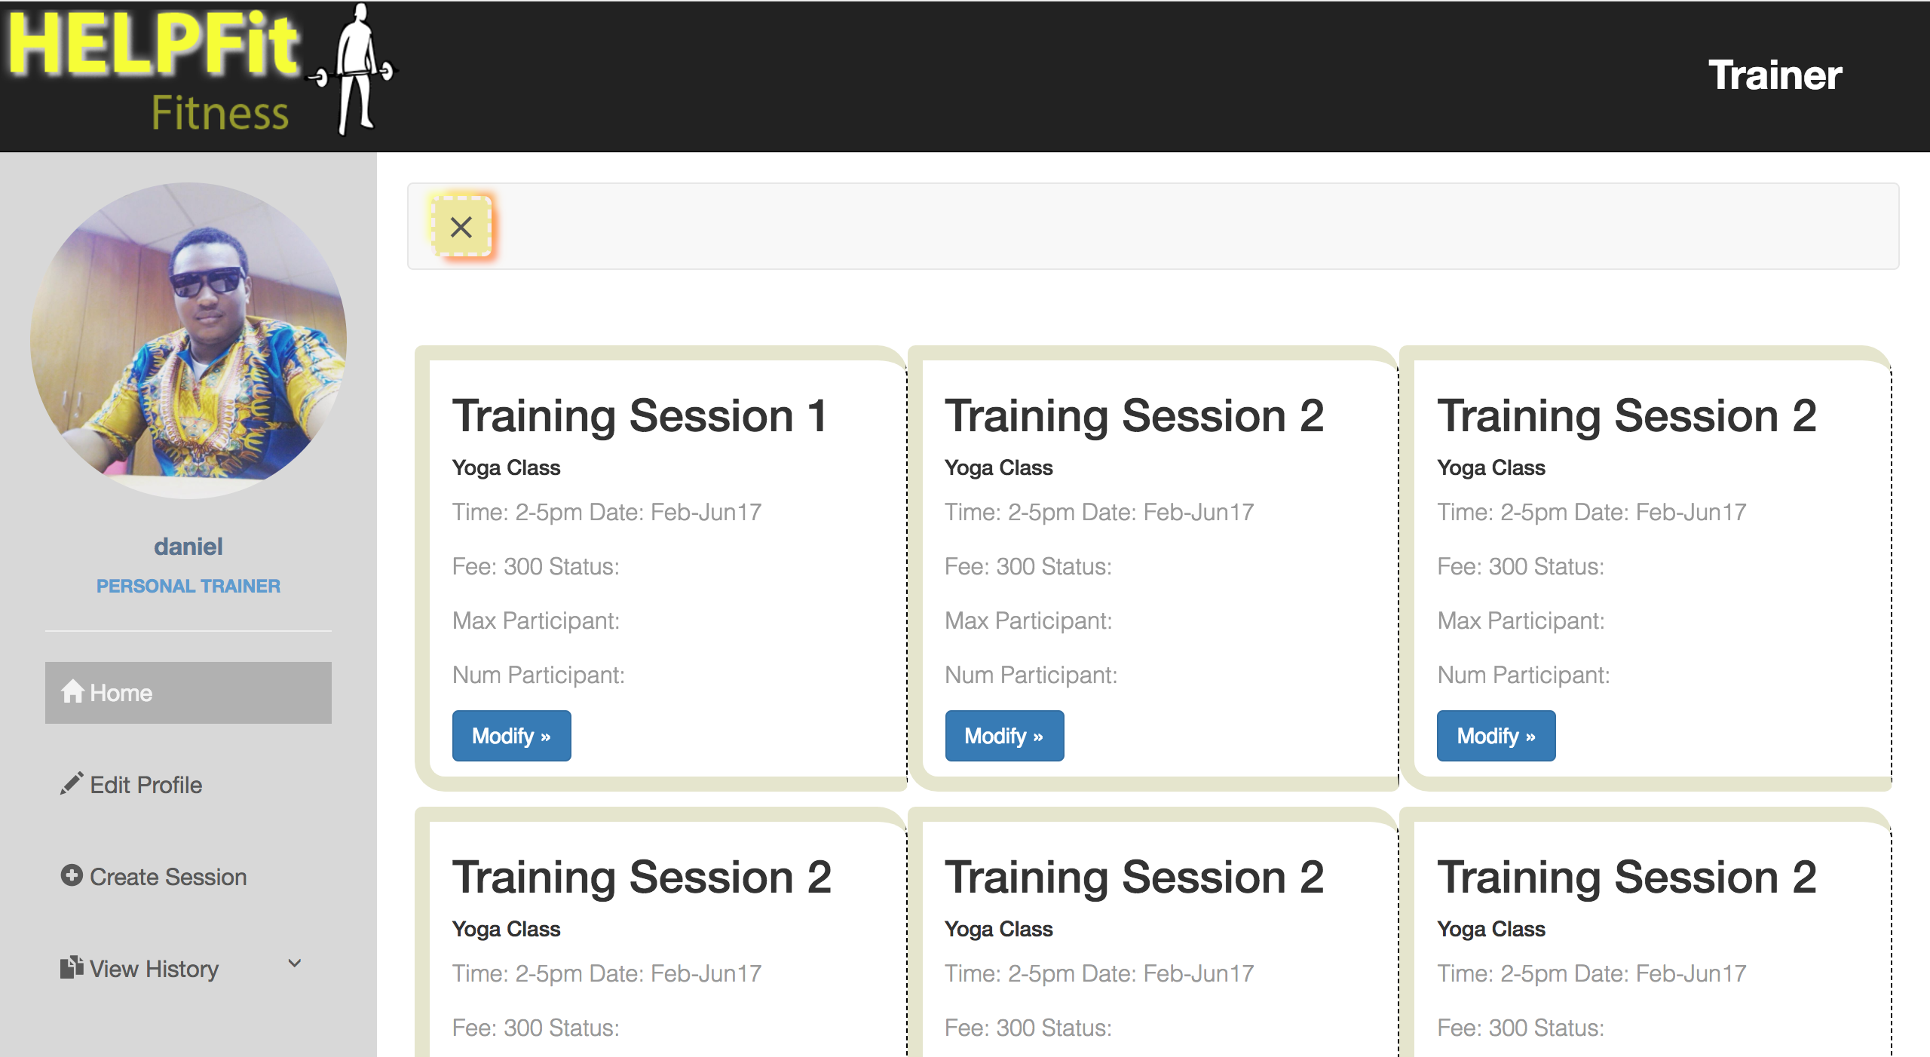Login page Trainer homepage

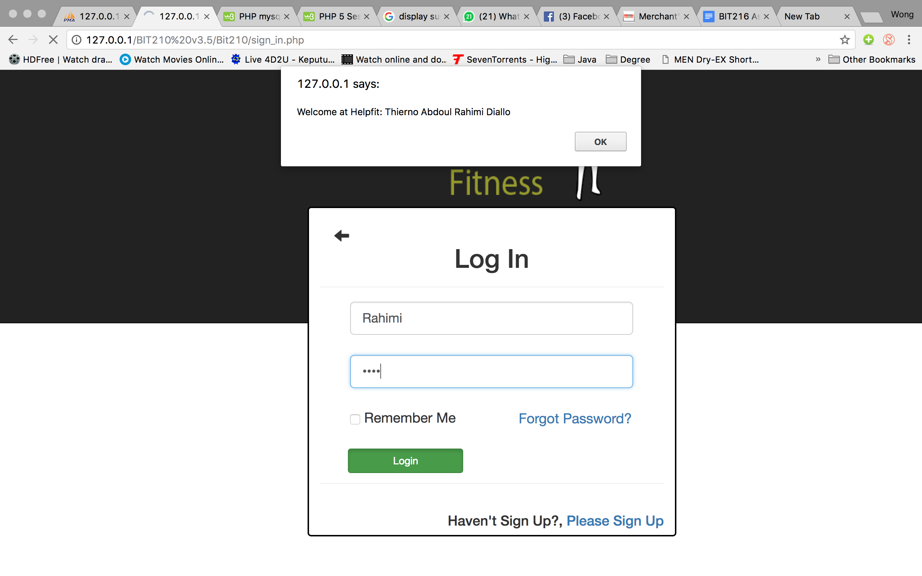

Test Case 7 -> Edit profile (Trainer)

|  |  |
| --- | --- |
| Input | Click on the sidebar edit profile |
| Expected Outcome | Edit profile page is directed |
| Actual Outcome | Edit profile page is directed |

Screen Capture:

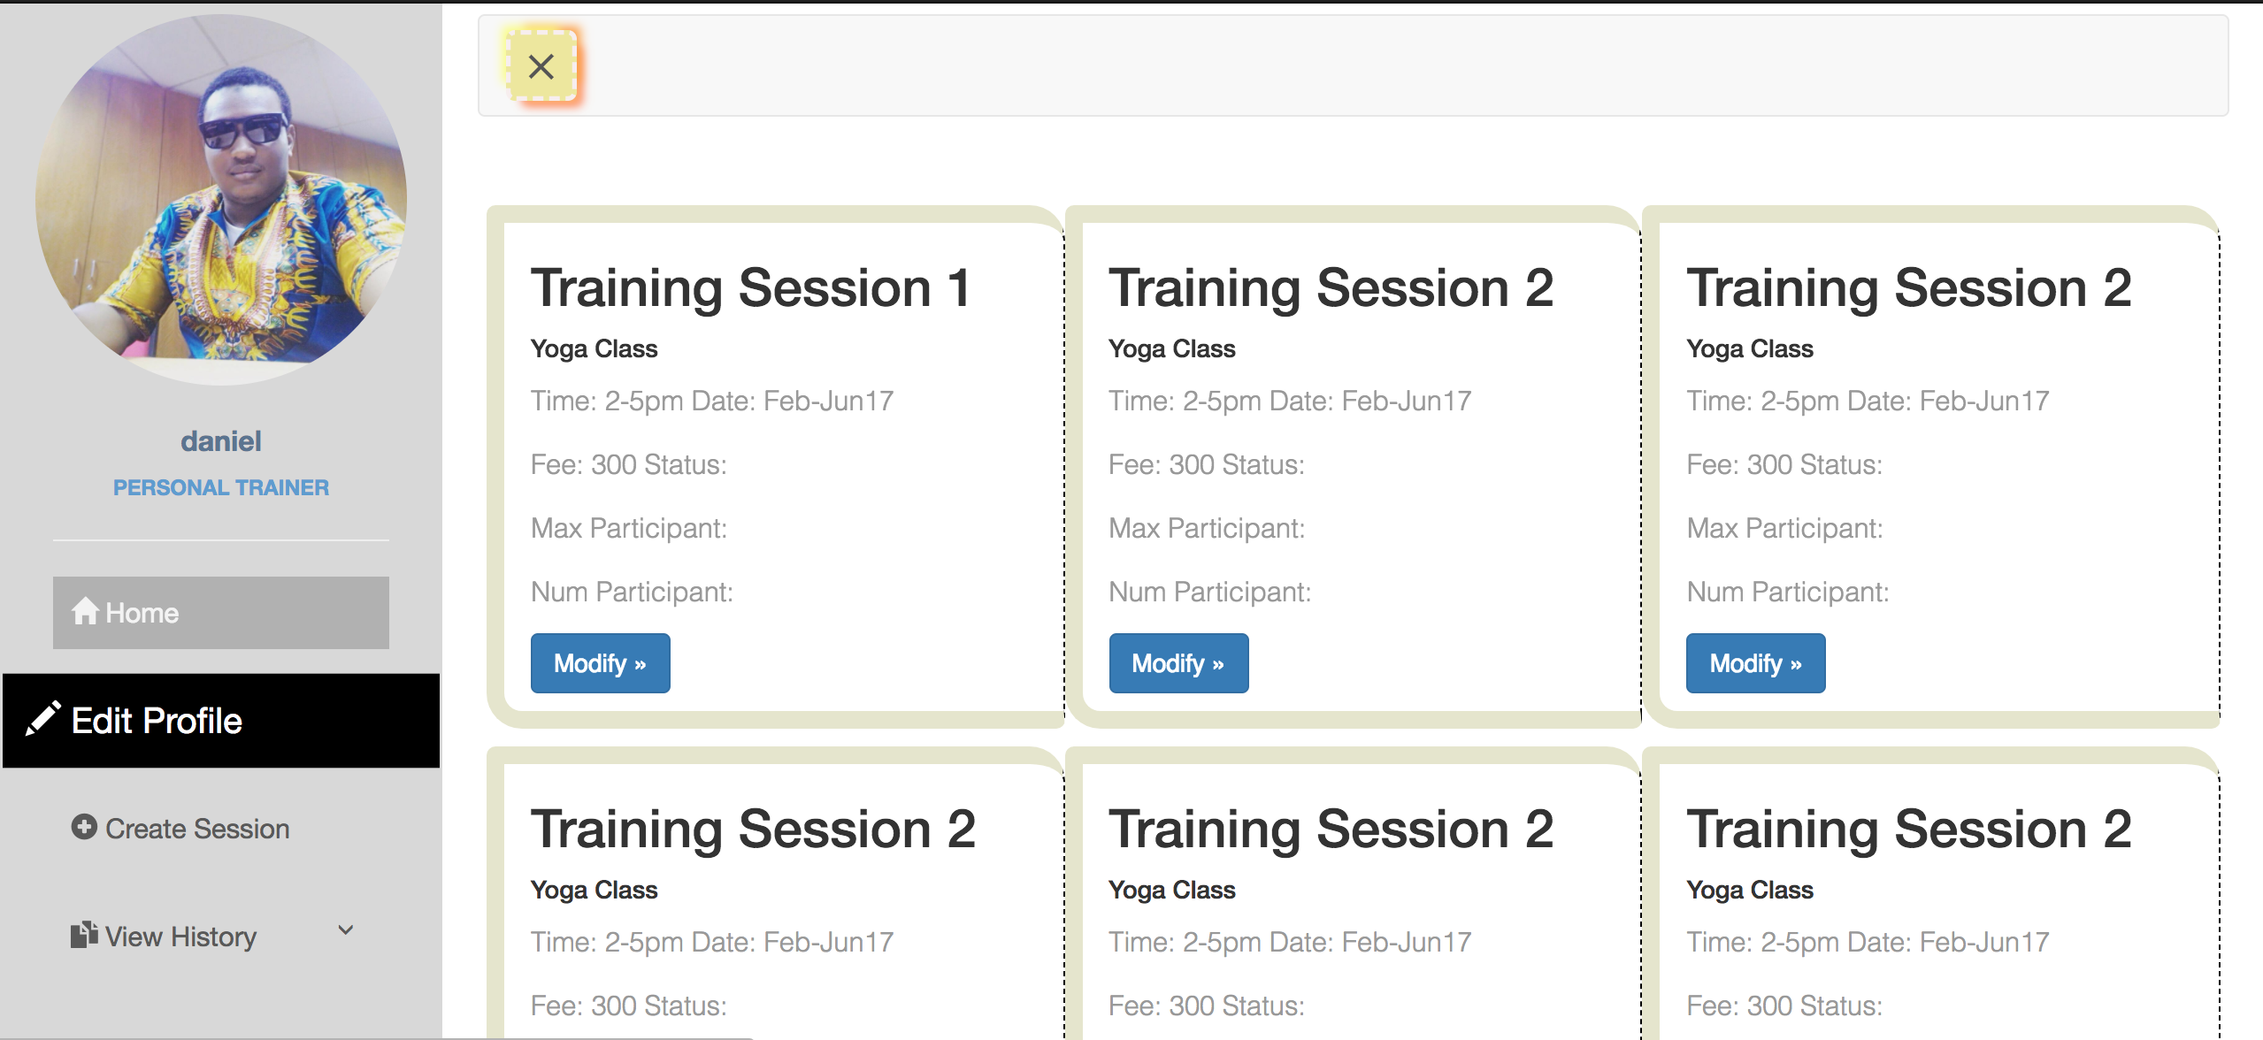Trainer Homepage Trainer Edit Profile page

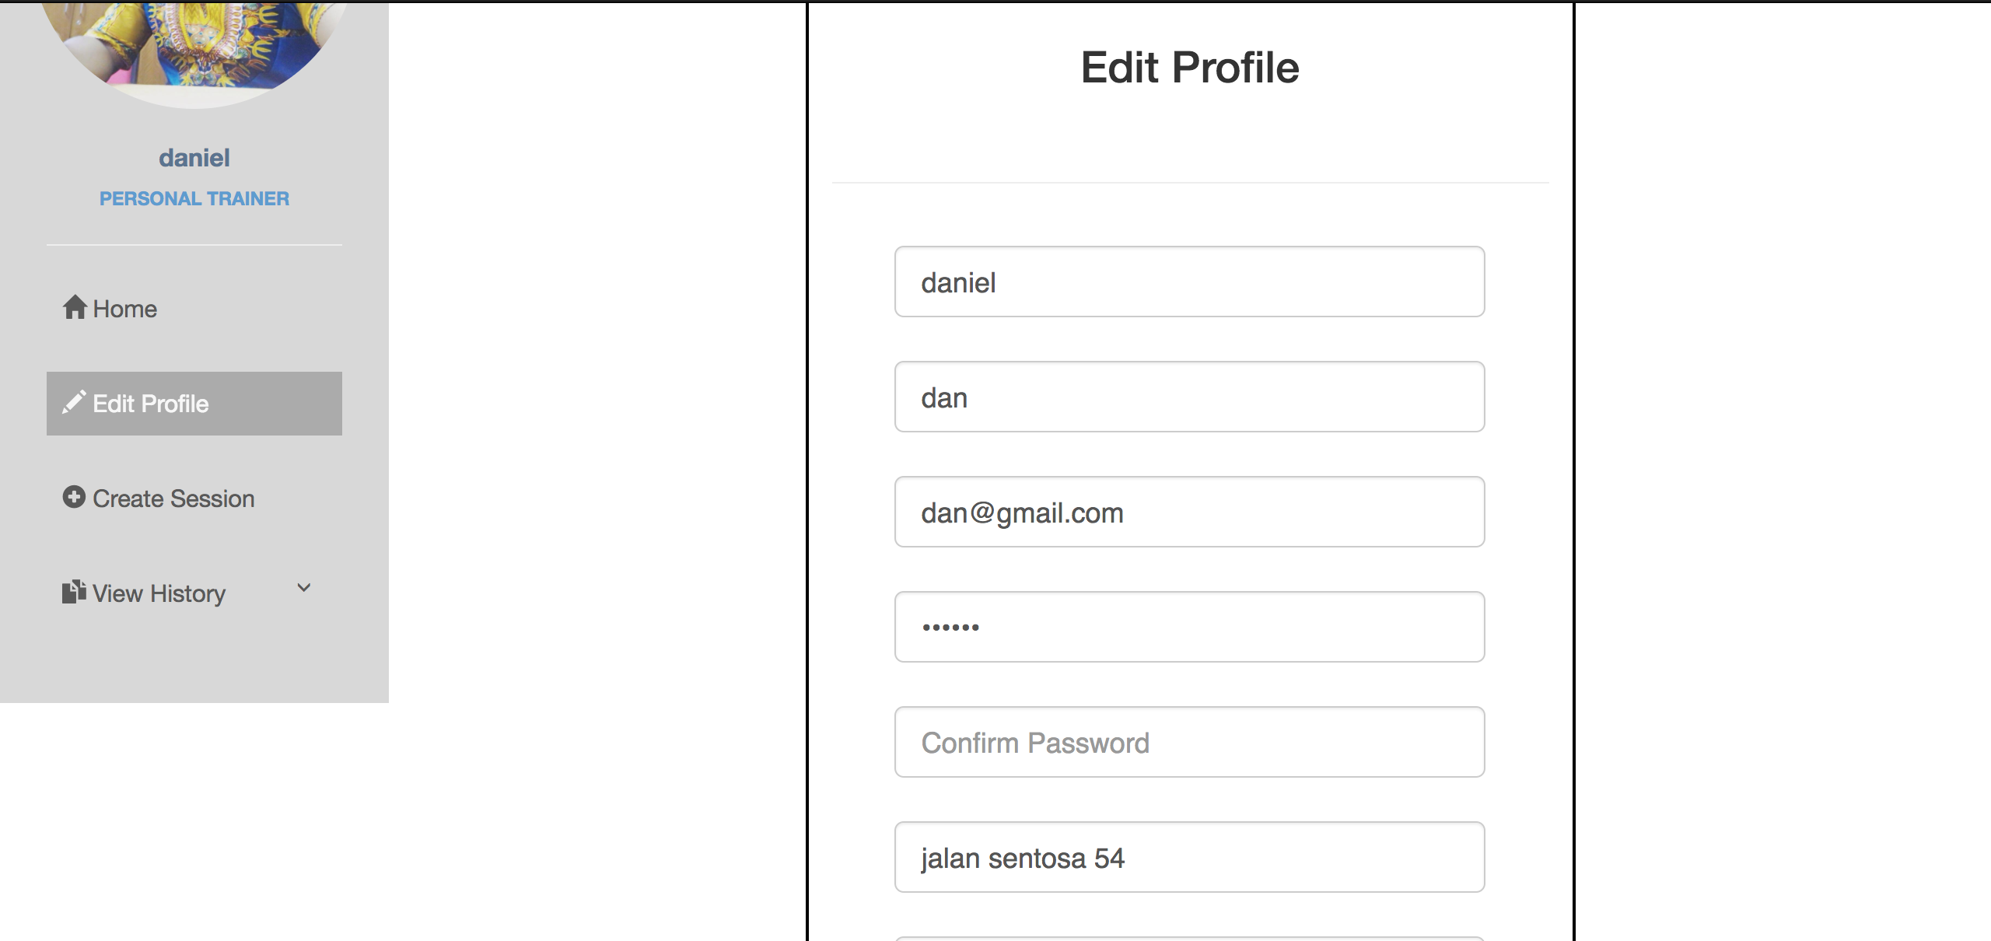

Test Case 4 -> Edit profile (Trainer)

|  |  |
| --- | --- |
| Input | Username = “dan”  Full Name = “dan”  Email address = “dan@gmail.com”  Password = “1234567”  Confirm Password = “1234567”  Address=”Jalan Sentosa 54”  Specialty = “Yoga Master” |
| Expected Outcome | A successful message is displayed, Edit profile page is directed |
| Actual Outcome | “Record edited successfully” Edit profile page is directed |

Screen Capture:

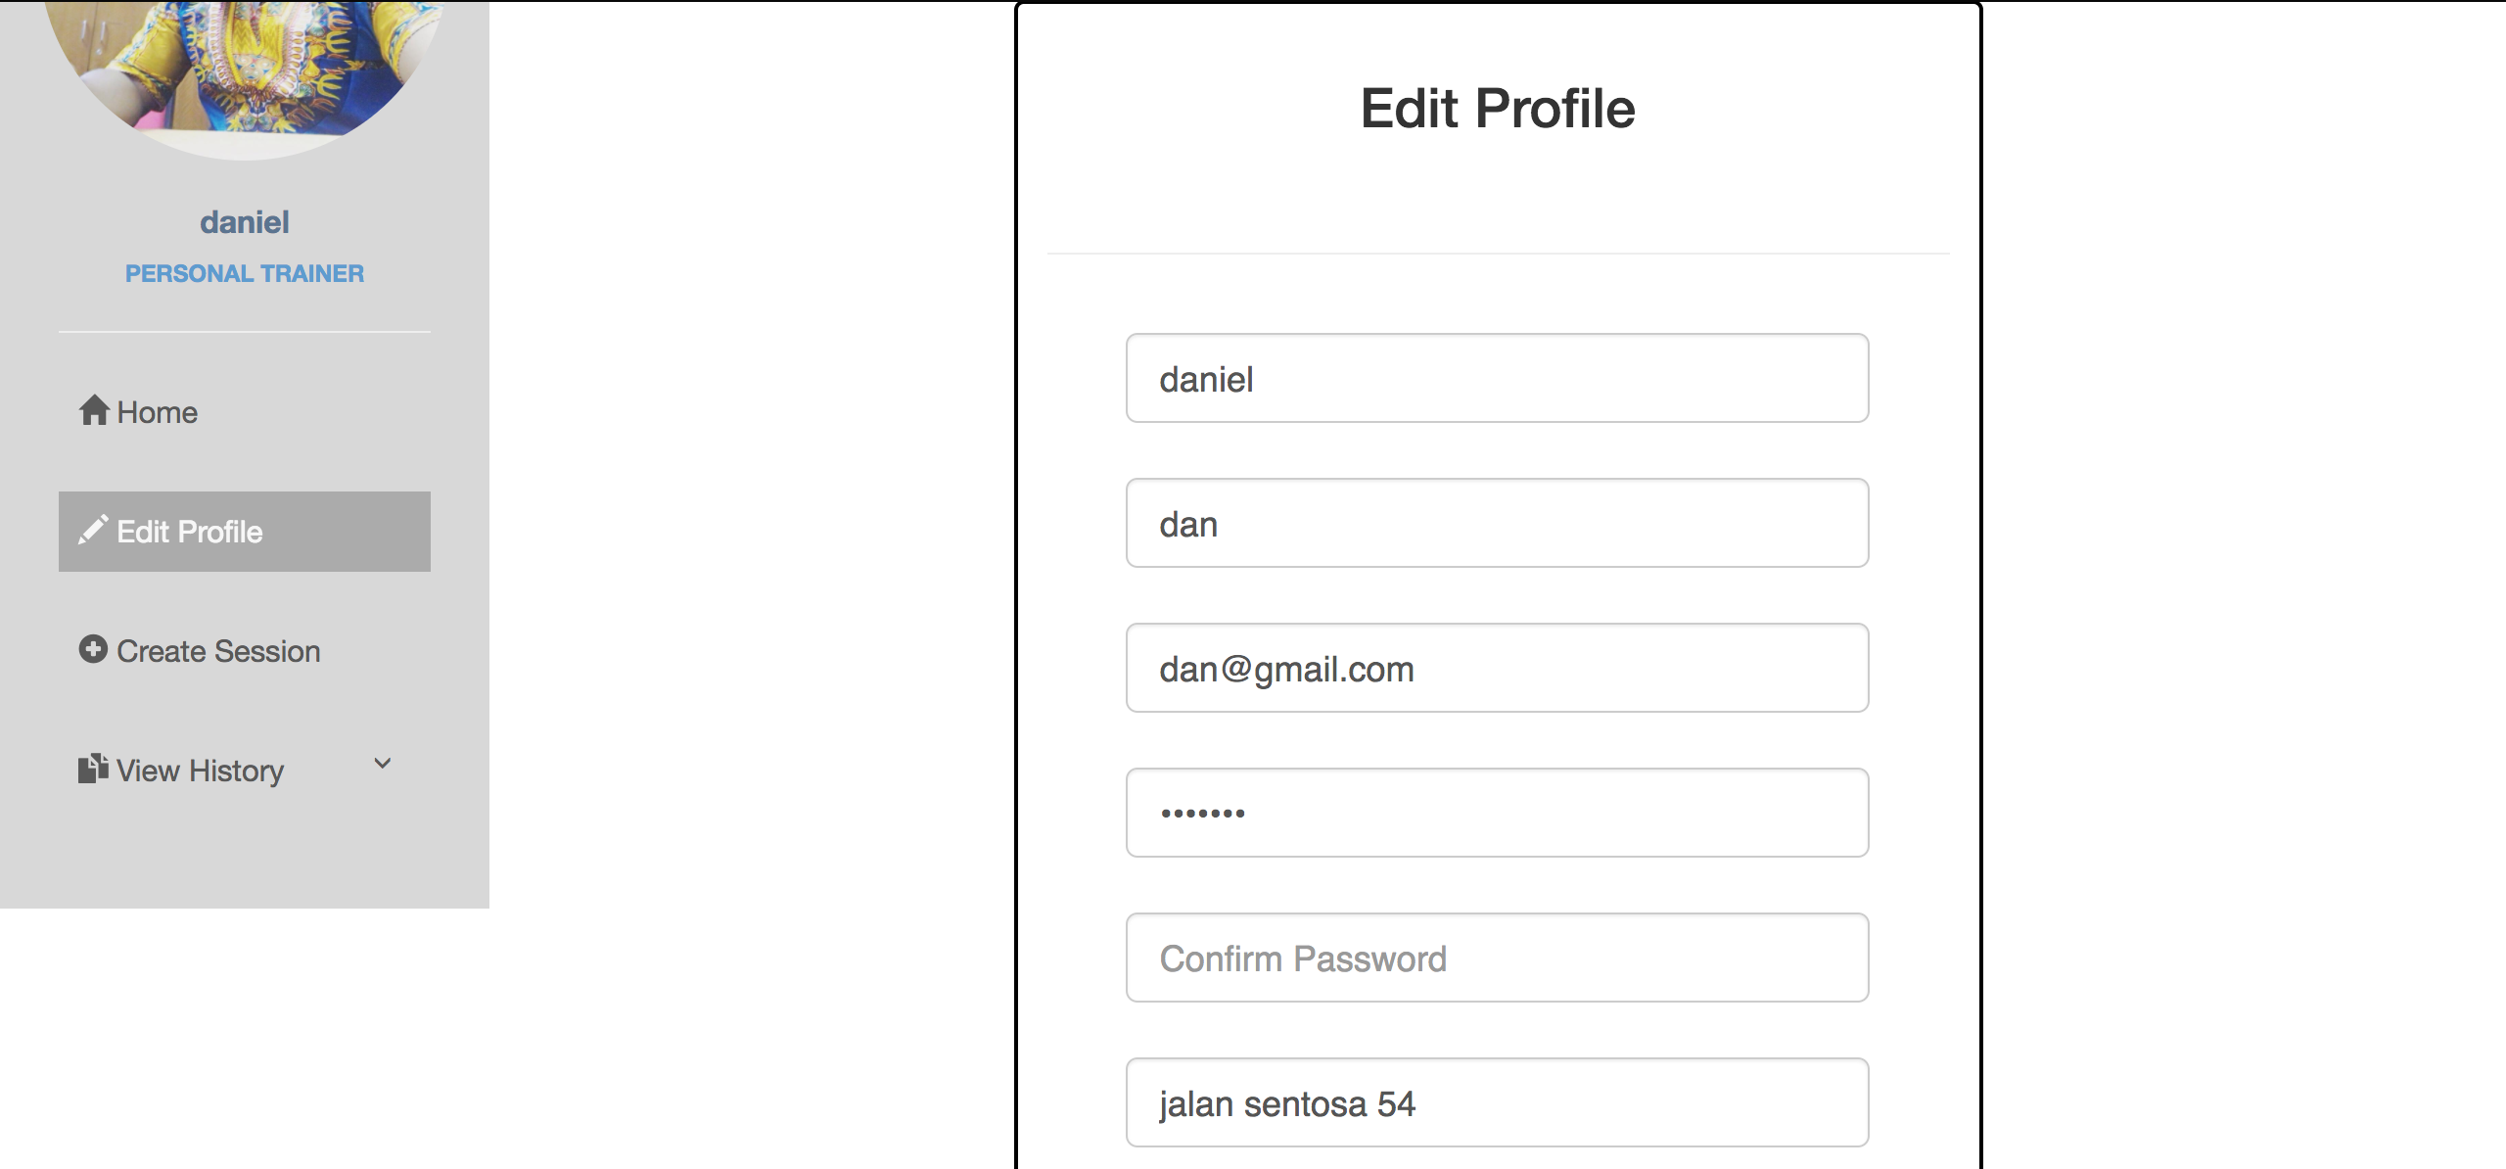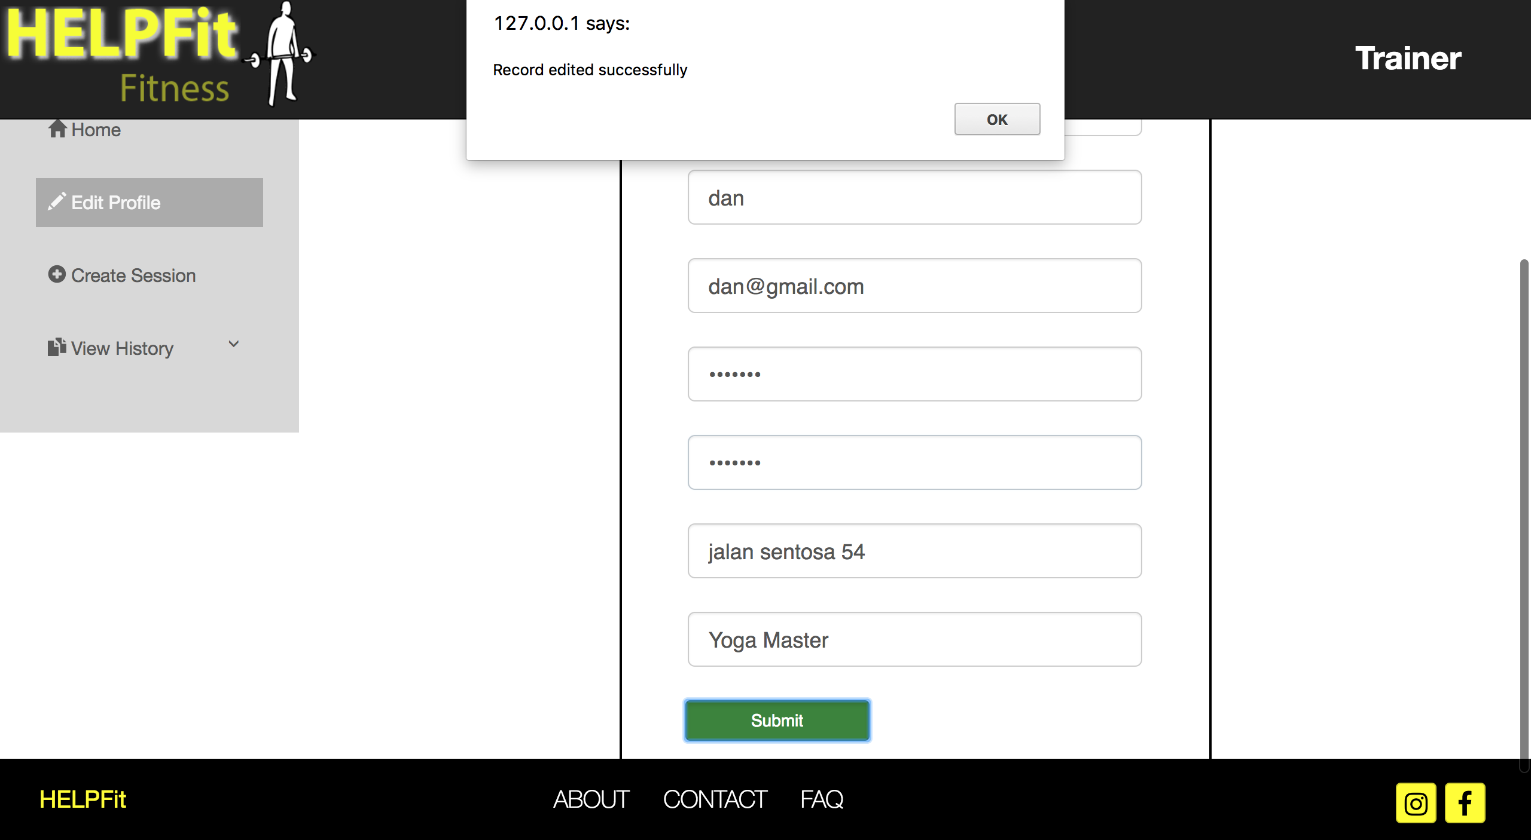Trainer Edit Profile Page with successful message Trainer Edit Profile Page

Integration Testing for Use case 2 Record New Training Session

Test Case 1 -> Login as a Trainer

|  |  |
| --- | --- |
| Input | Username = “dan”  Password = “123456” |
| Expected Outcome | A successful message is shown and trainer homepage is directed |
| Actual Outcome | “Welcome!”, trainer homepage is directed |

Screen capture:

Login page Trainer homepage



Test Case 2 -> Record Training Session Personal

|  |  |
| --- | --- |
| Input | Click on the sidebar Create Session and select Personal button |
| Expected Outcome | Training Session Selection page is directed and Record Personal Training Session is directed |
| Actual Outcome | Training Session Selection page is directed and Record Personal Training Session is directed |

Screen Capture:

Trainer Homepage Trainer Record New Training Session

Selection page

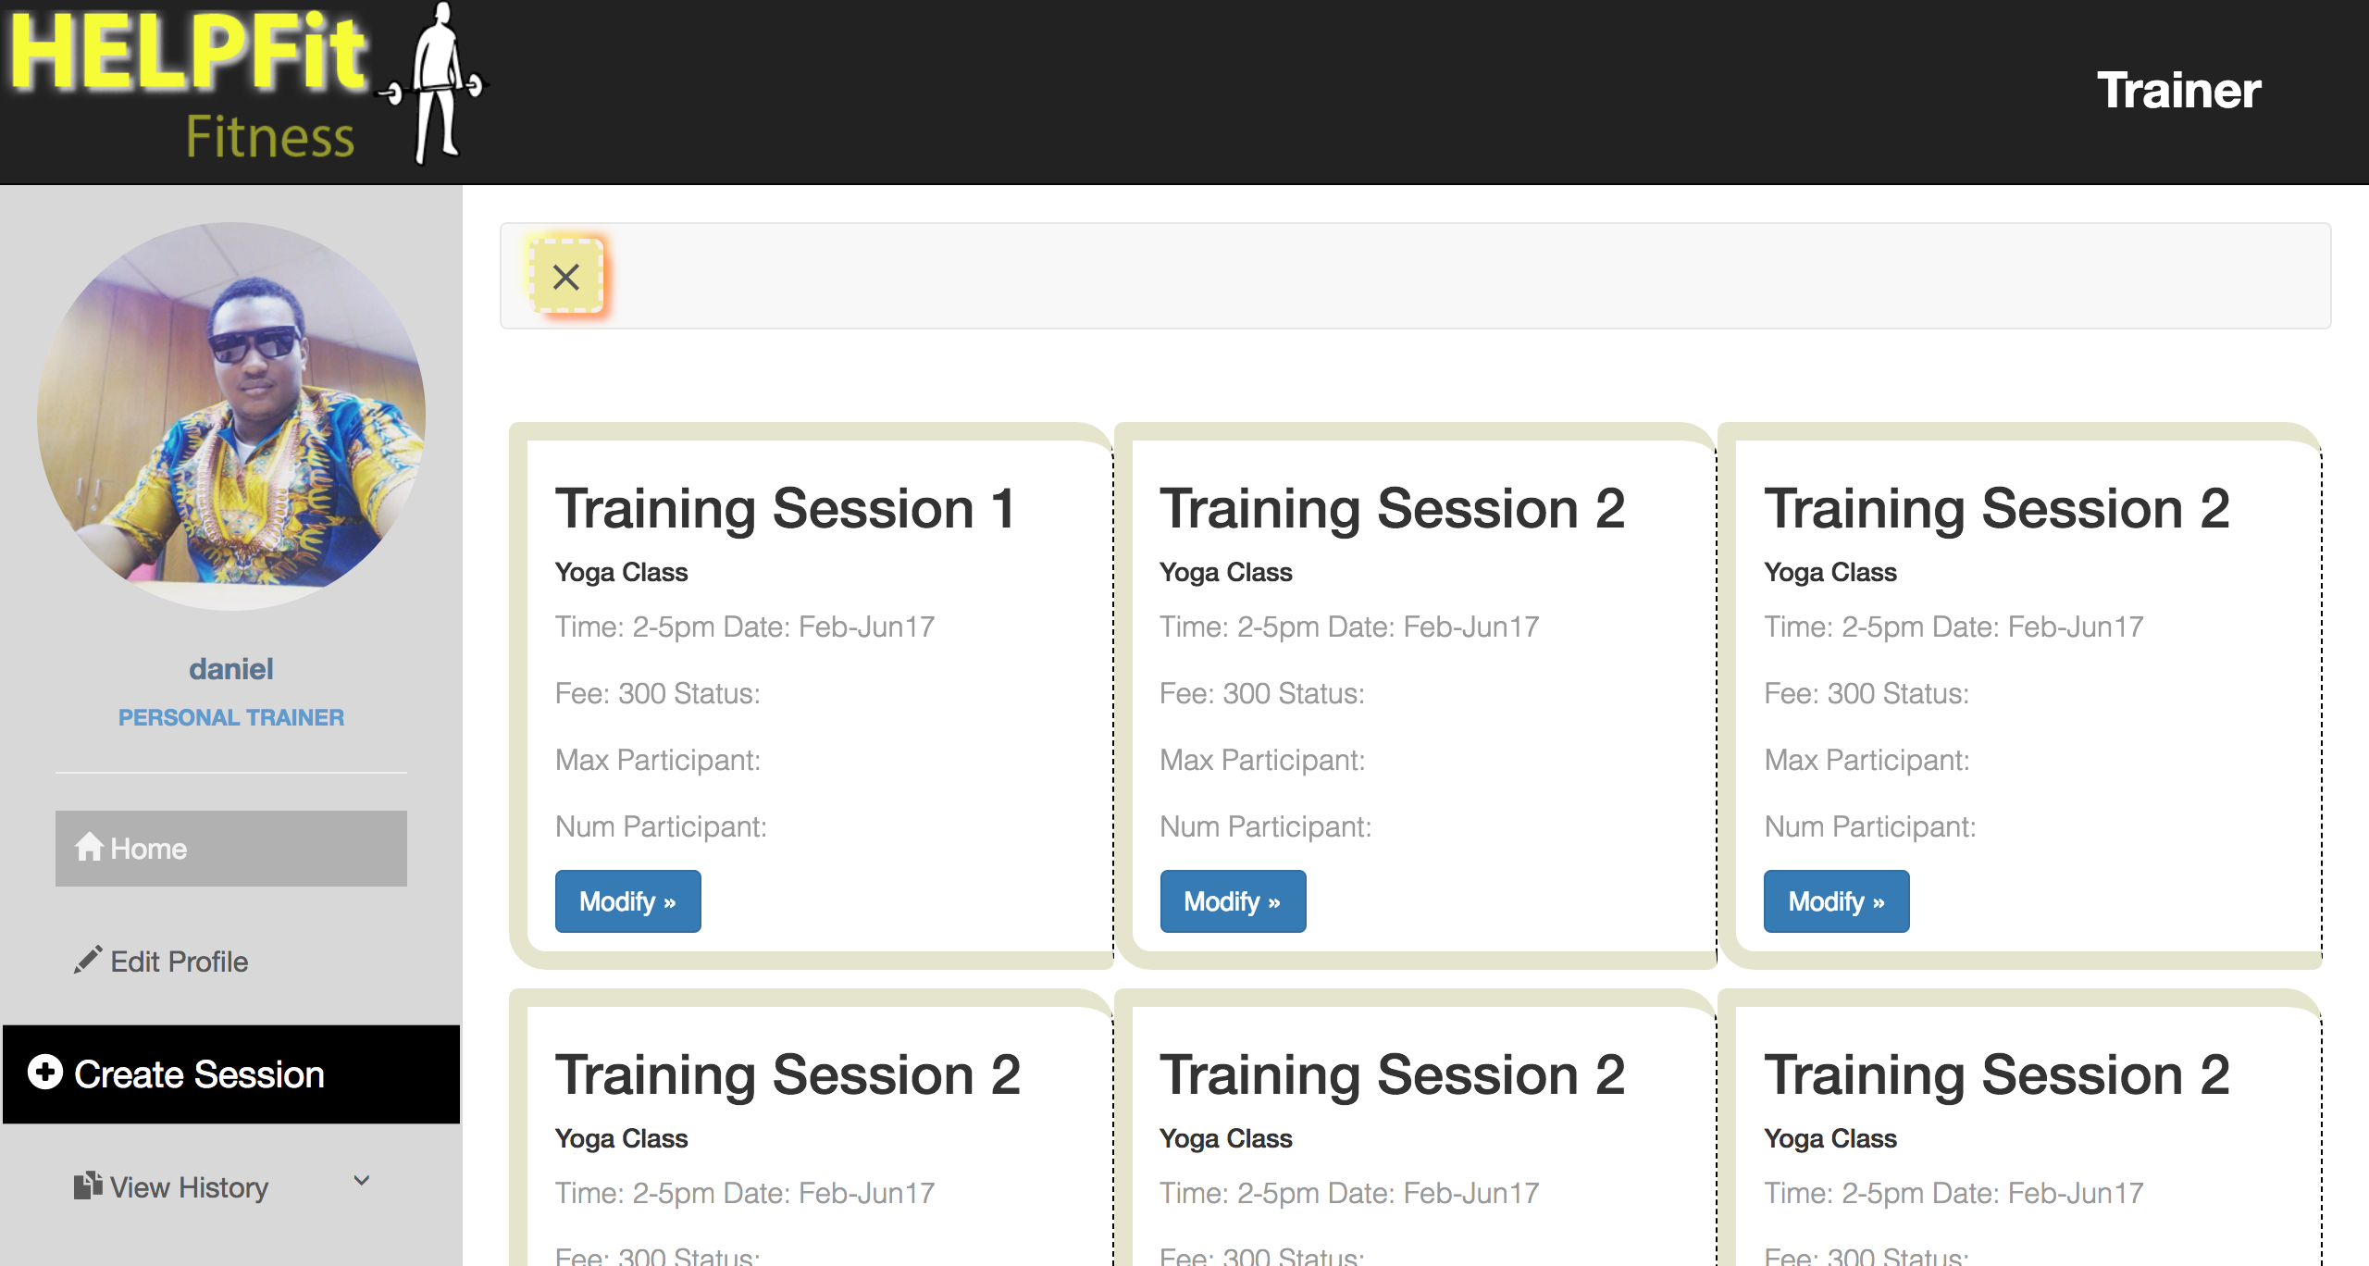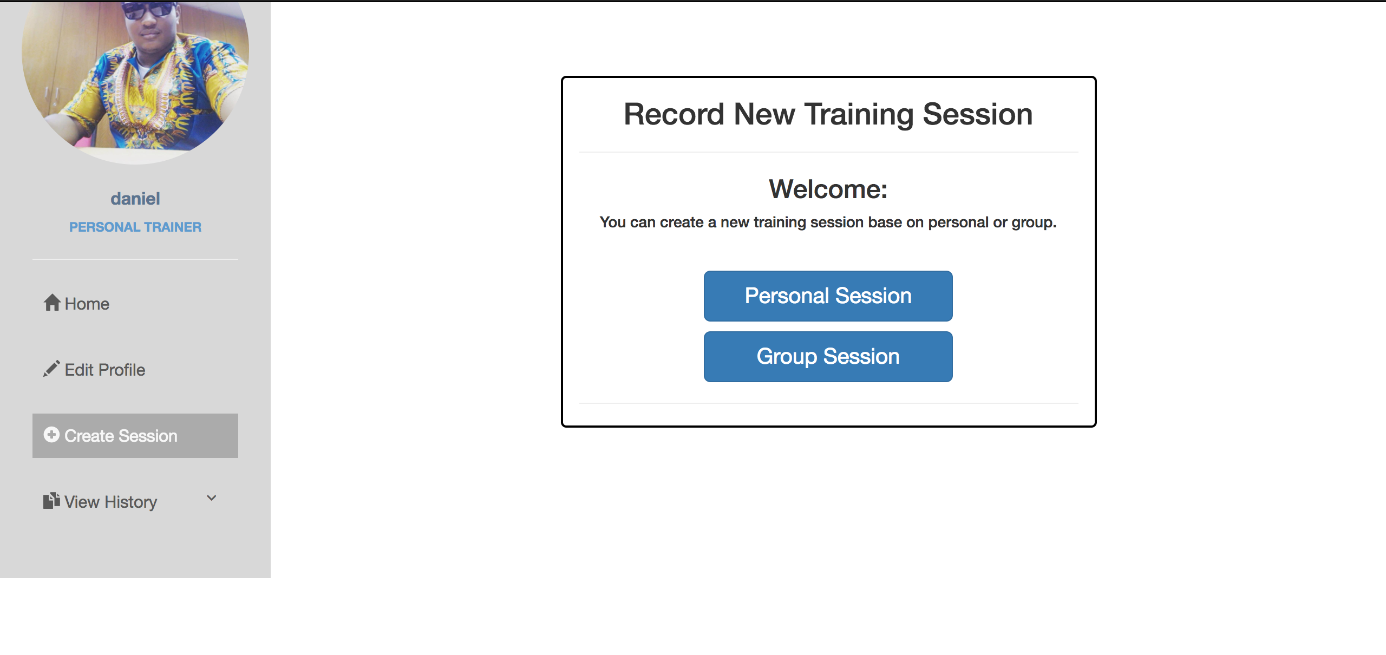

Personal Re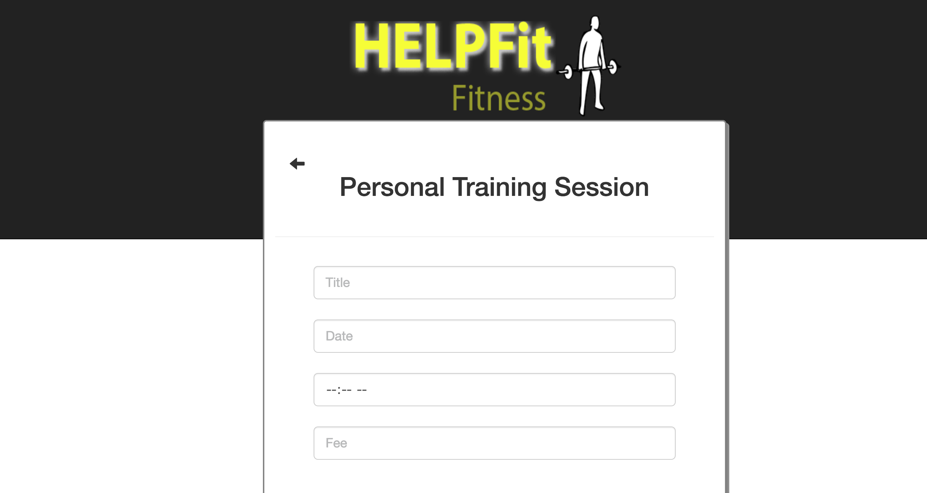cord New Training Session

Test Case 3 -> Record New Personal Training Session

|  |  |
| --- | --- |
| Input | Title = “Yoga Class 1”  Date = “24 October 2017”  Time = “10:00AM”  Fee = “1000” |
| Expected Outcome | A successful message is shown and Personal Training Session Page is directed |
| Actual Outcome | “Record added successfully!”, Personal Training Session Page is directed |

Screen Capture:

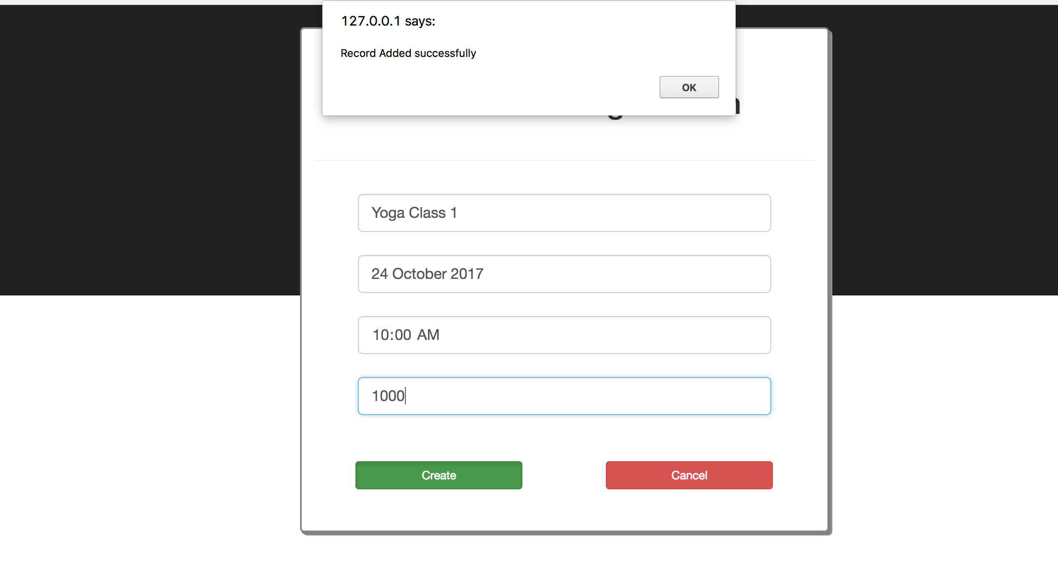Personal Record New Training Session Personal Record New Training Session

Test Case 4 -> Record Training Session Group

|  |  |
| --- | --- |
| Input | Click on the sidebar Create Session and select Group button |
| Expected Outcome | Training Session Selection page is directed and Record Personal Training Session is directed |
| Actual Outcome | Training Session Selection page is directed and Record Personal Training Session is directed |

Screen Capture:

Trainer Homepage Trainer Record New Training Session

Selection page



Group Record New Training

Session

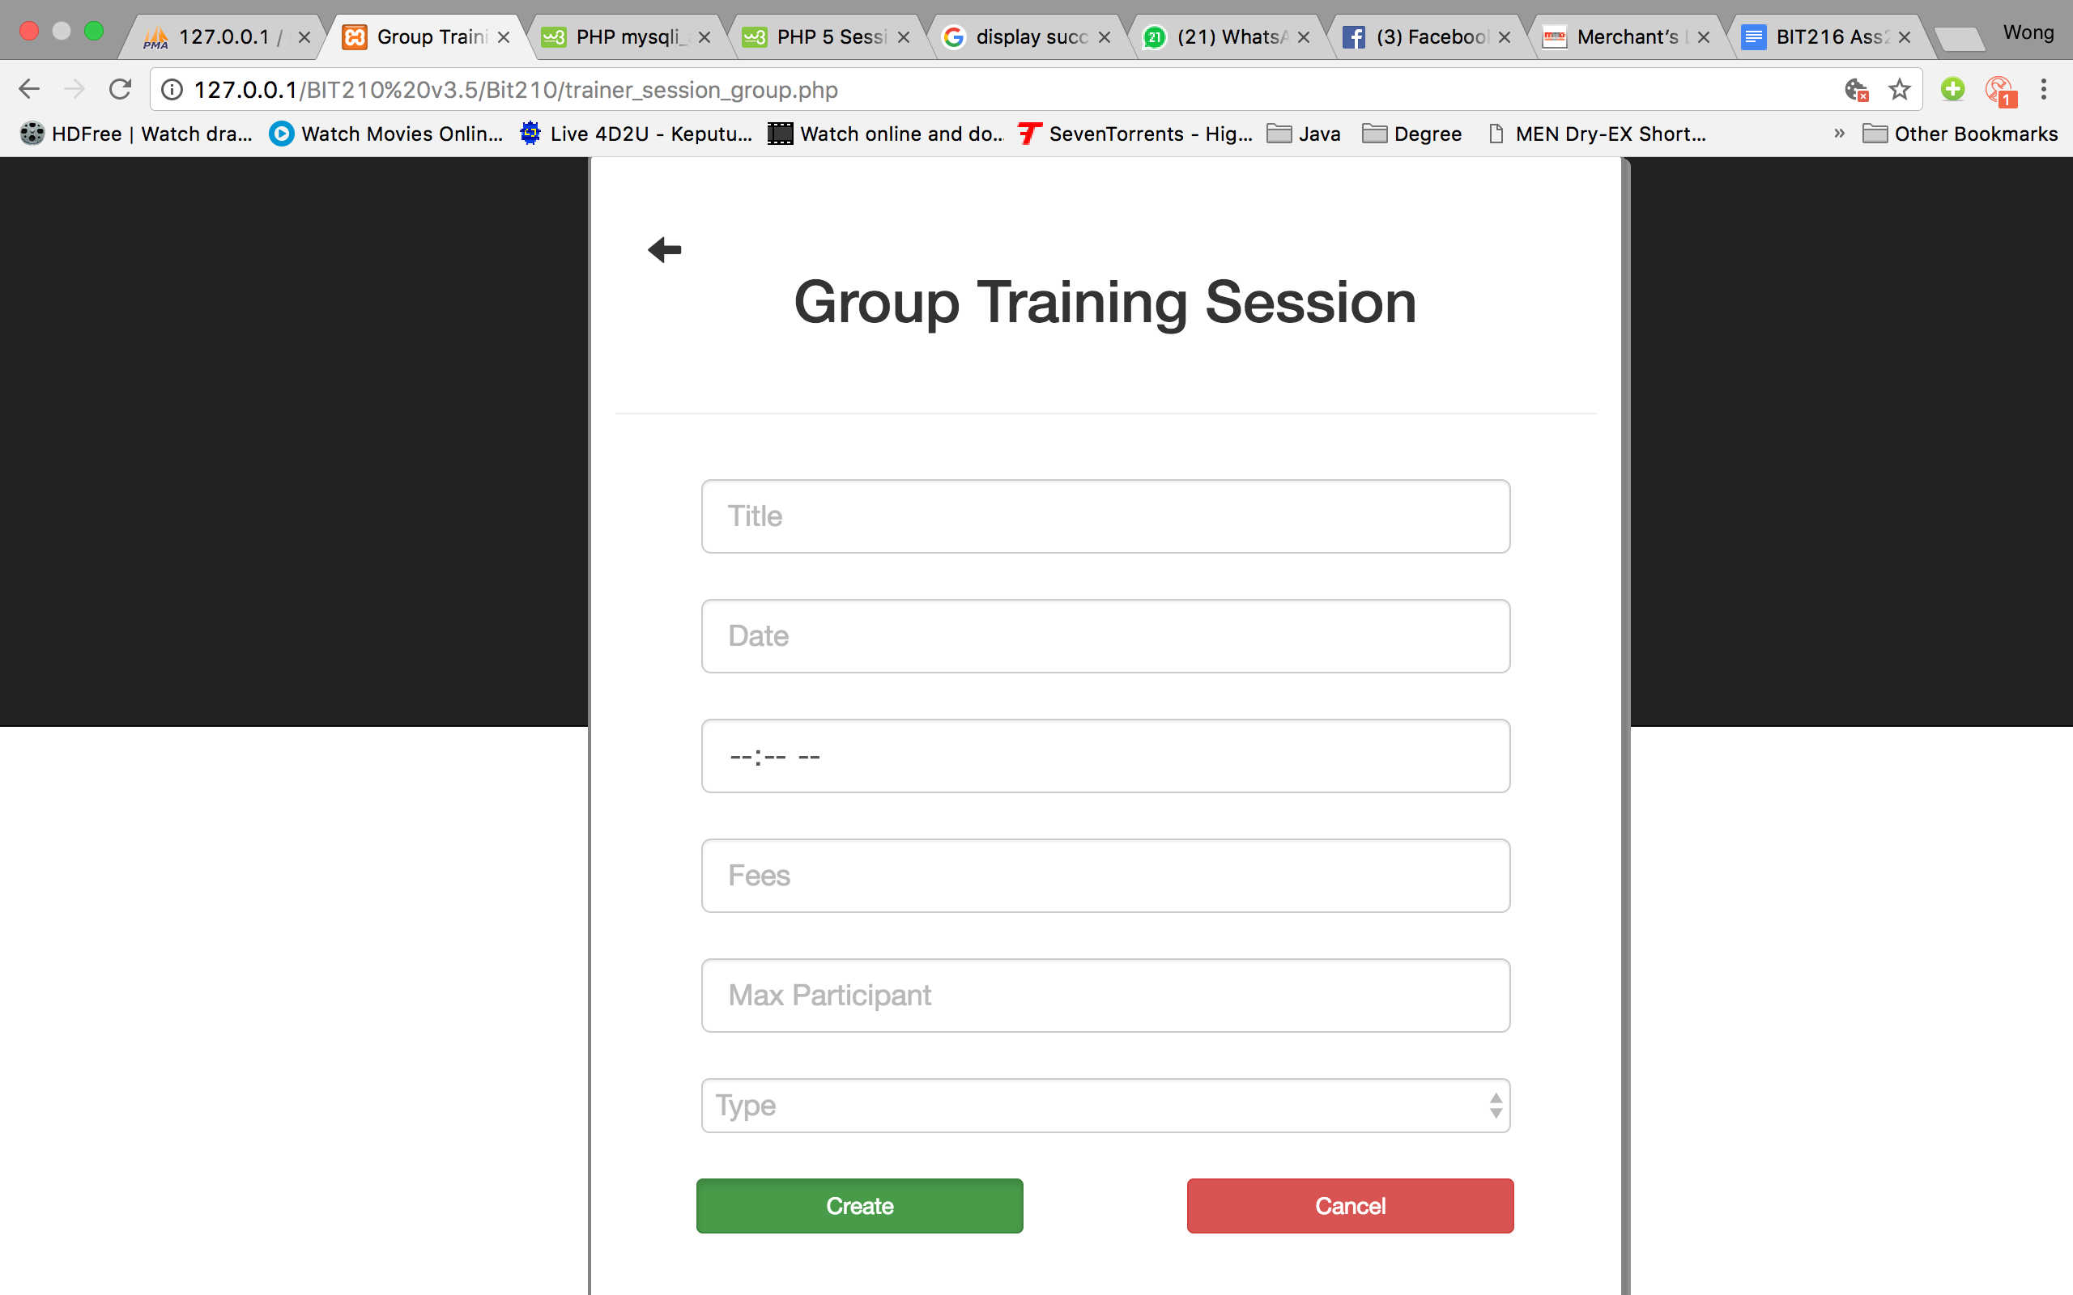

Test Case 5 -> Record New Group Training Session

|  |  |
| --- | --- |
| Input | Title = “Abs Training Class 1”  Date = “24 October 2017”  Time = “10:00AM”  Fee = “1000”  Max Participant =”20”  Type=”Sport” |
| Expected Outcome | A successful message is shown and Group Training Session Page is directed |
| Actual Outcome | “Record added successfully!”, Group Training Session Page is directed |

Screen capture:

Group Record New Training Session 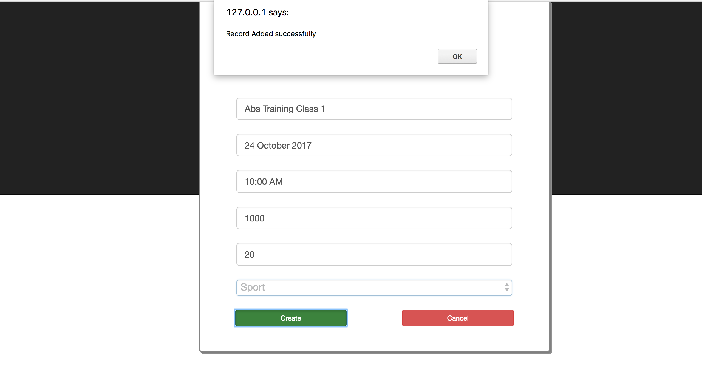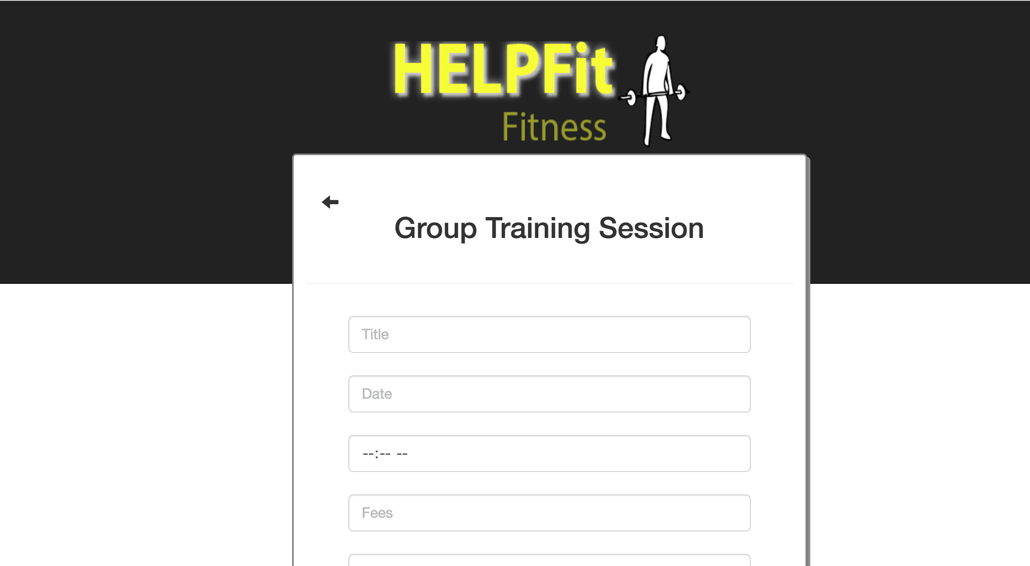 Group Record New Training Session

Use Case 3 Register for Training Session

Test Case 1 -> Login as a Member

|  |  |
| --- | --- |
| Input | Username = “dan”  Password = “123456” |
| Expected Outcome | A successful message is shown and trainer homepage is directed |
| Actual Outcome | “Welcome!”, trainer homepage is directed |

Screen capture:

Login page Member homepage

Test Case 2 -> Register Personal Training Session

|  |  |
| --- | --- |
| Input | Click on the sidebar Register Training Session and select Personal button |
| Expected Outcome | Personal Registration Training Session page is directed |
| Actual Outcome | Personal Registration Training Session page is directed |

Screen Capture:

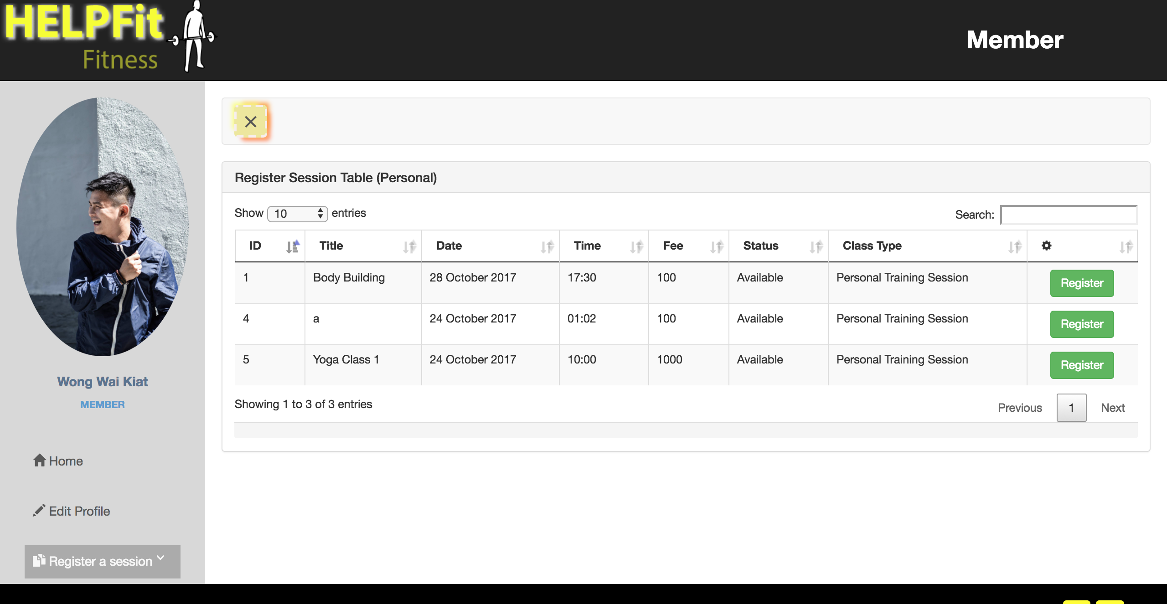Member Homepage Personal Register Training Session Page

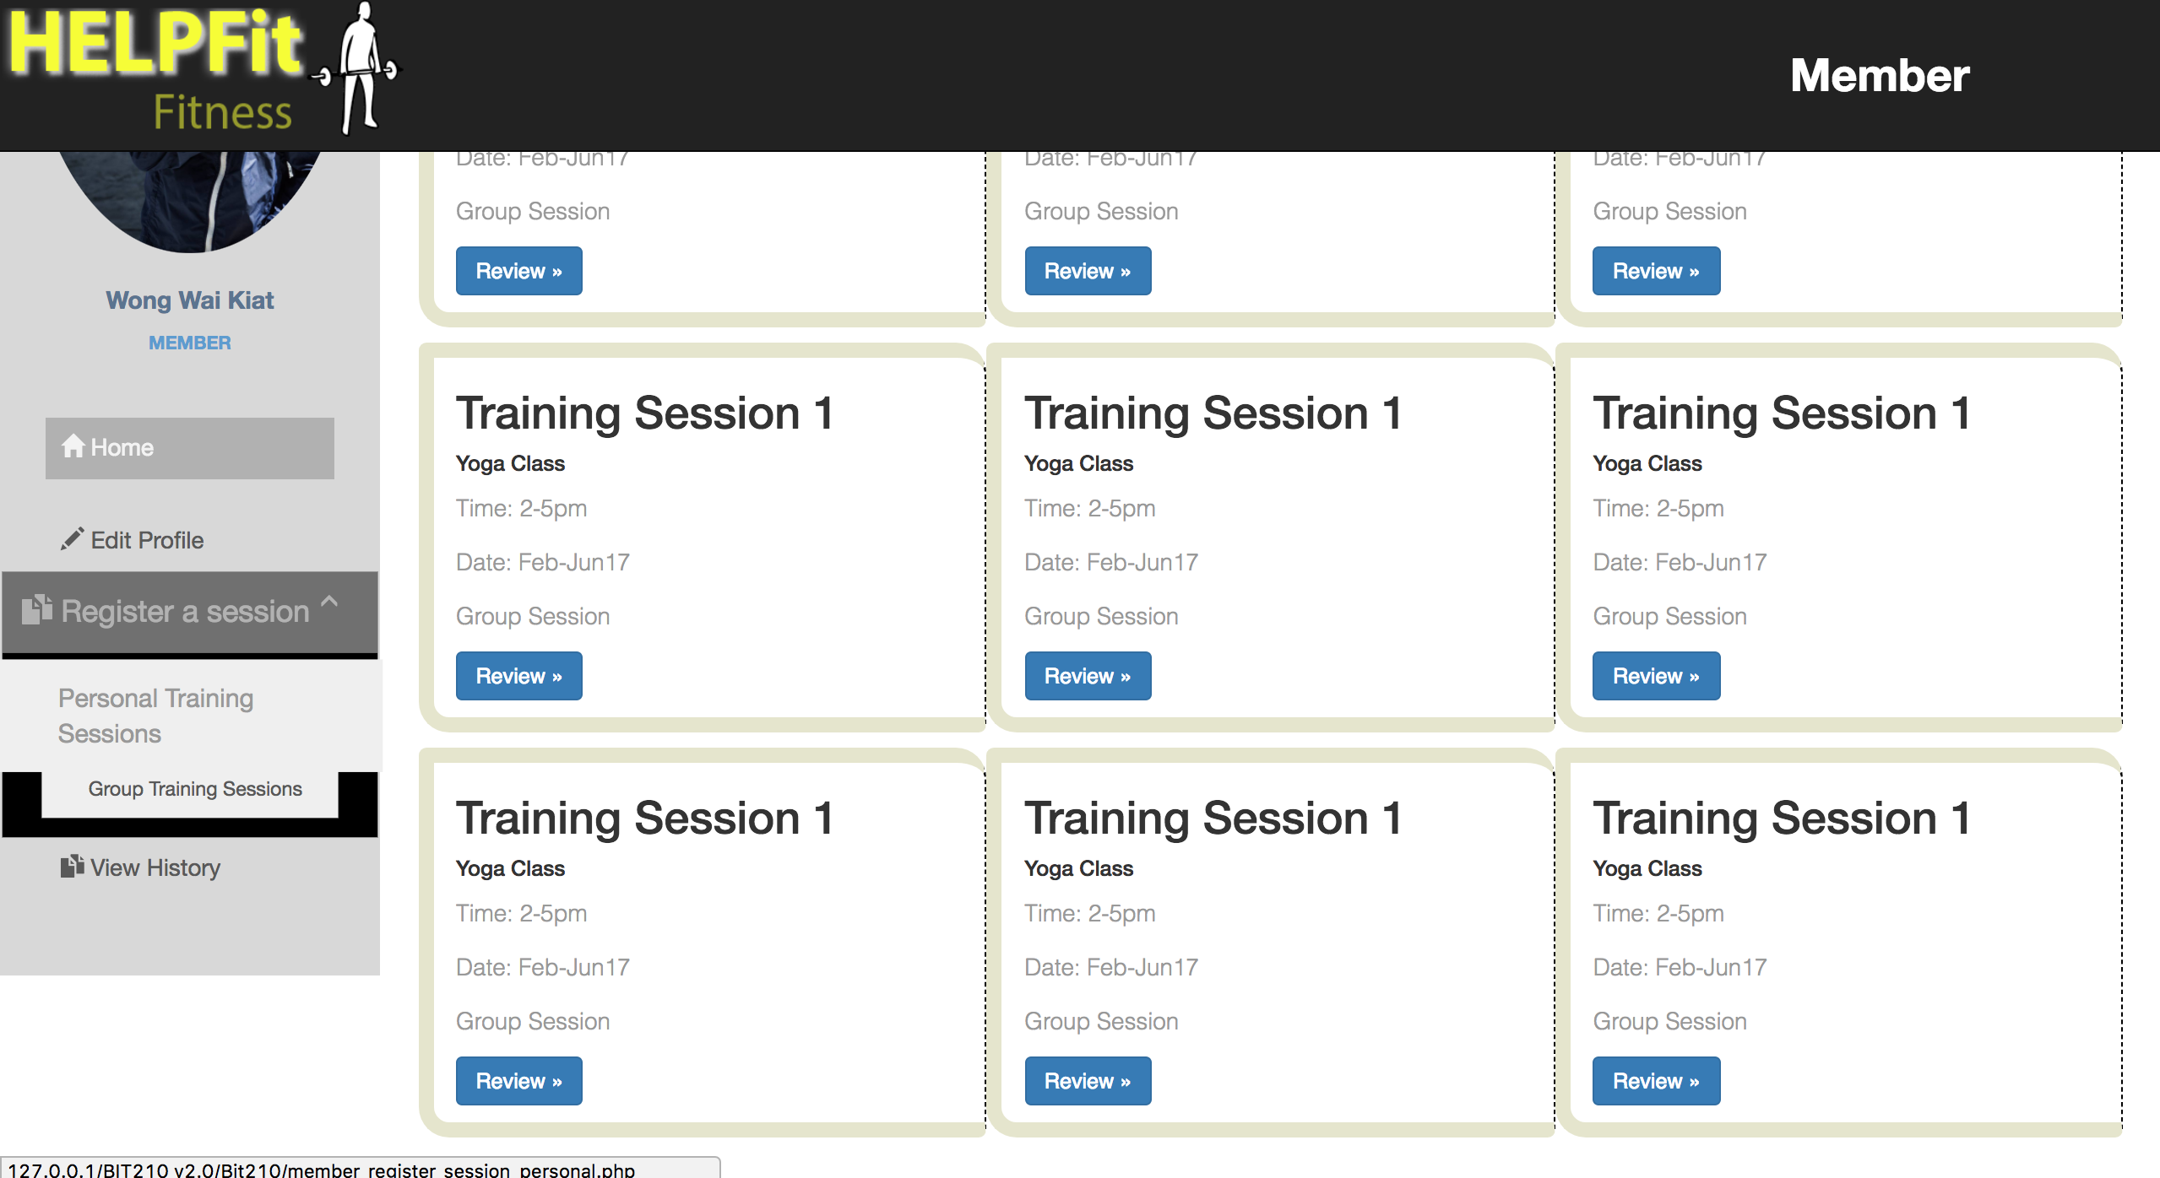

Test Case 3 -> Register Group Training Session

|  |  |
| --- | --- |
| Input | Click on the sidebar Register Training Session and select Group button |
| Expected Outcome | Group Registration Training Session page is directed |
| Actual Outcome | Group Registration Training Session page is directed |

Screen Capture:

Member Homepage Group Register Training Session Page

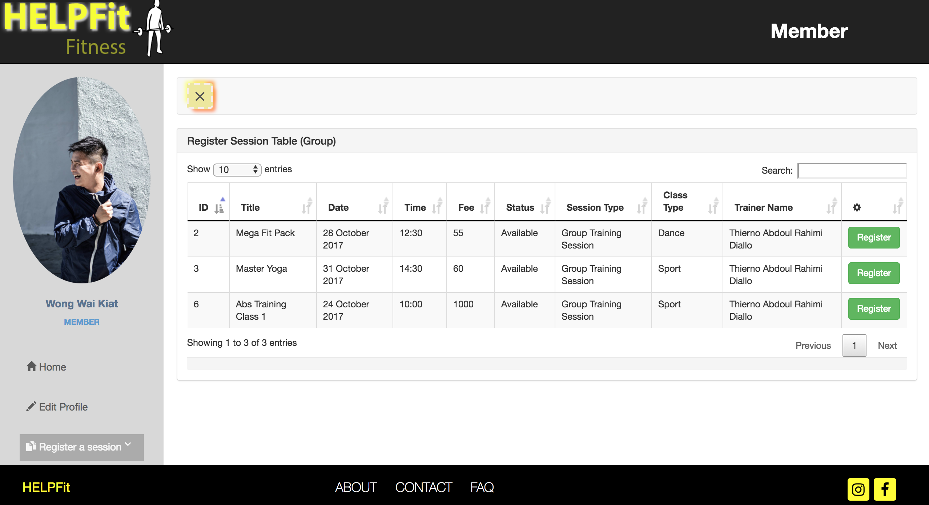

Test Case 4 -> Register Personal Training Session

|  |  |
| --- | --- |
| Input | Click on the register button at the end of the column in the table to register |
| Expected Outcome | Successful message is display and directed back to Personal Register Training Session Page |
| Actual Outcome | Personal Registration Training Session page is directed |

Personal Registration Training Session page Personal Registration Training Session

page with successful added message

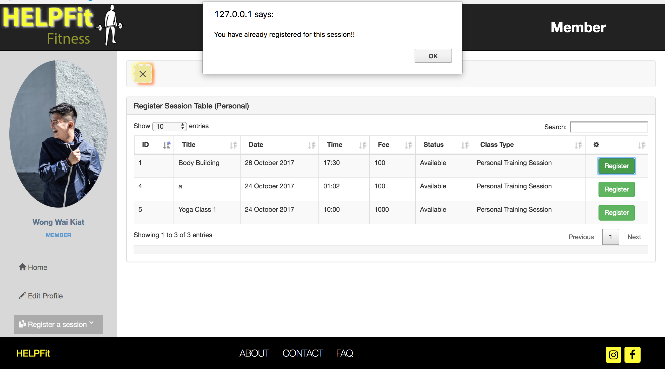

Personal Registration Training Session

page

Test Case 5 -> Register Group Training Session

|  |  |
| --- | --- |
| Input | Click on the register button at the end of the column in the table to register |
| Expected Outcome | Successful message is display and directed back to Group Register Training Session Page |
| Actual Outcome | Personal Registration Training Session page is directed |



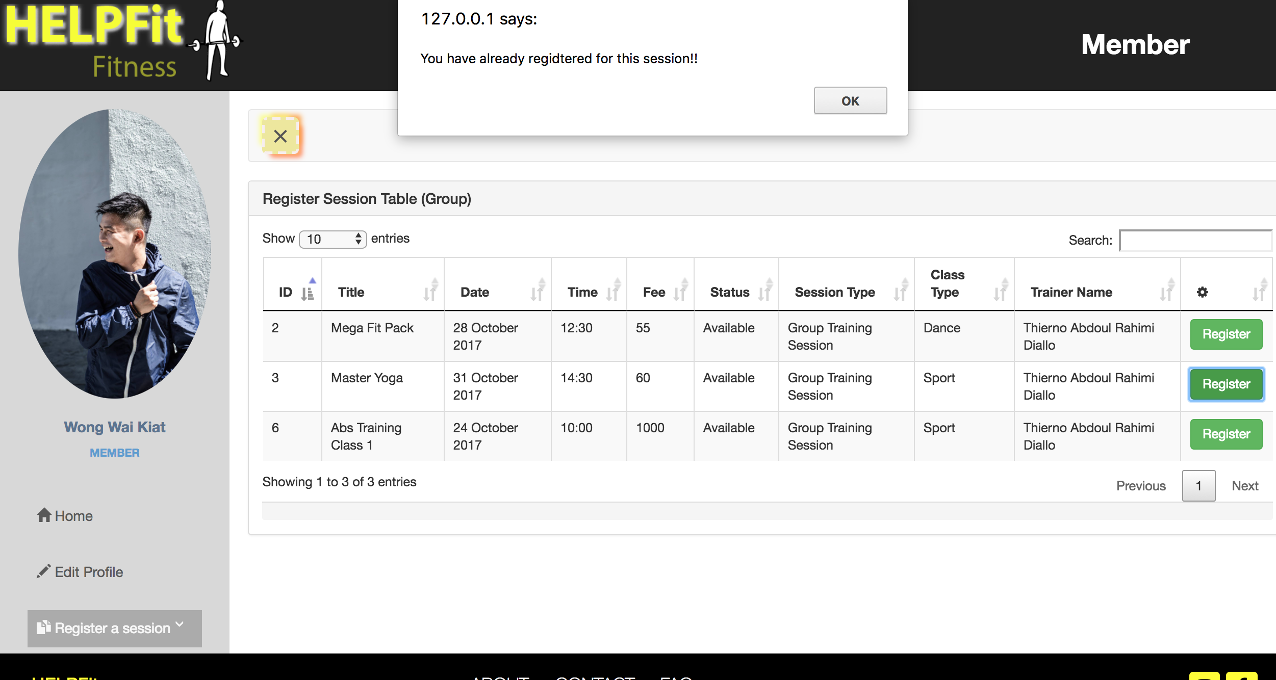



Integration Testing for Use case 4: View Training History (Member)

Test Case 1 -> Login as a Member

|  |  |
| --- | --- |
| Input | Username = “dan”  Password = “123456” |
| Expected Outcome | A successful message is shown and trainer homepage is directed |
| Actual Outcome | “Welcome!”, trainer homepage is directed |

Screen capture:

Login page Member homepage

Test Case 2 -> View History Training Table

|  |  |
| --- | --- |
| Input | Click on the sidebar, View History tab to go to the Training Session History Page |
| Expected Outcome | Training Session History Page is directed |
| Actual Outcome | Training Session History Page is directed |

Screen capture:

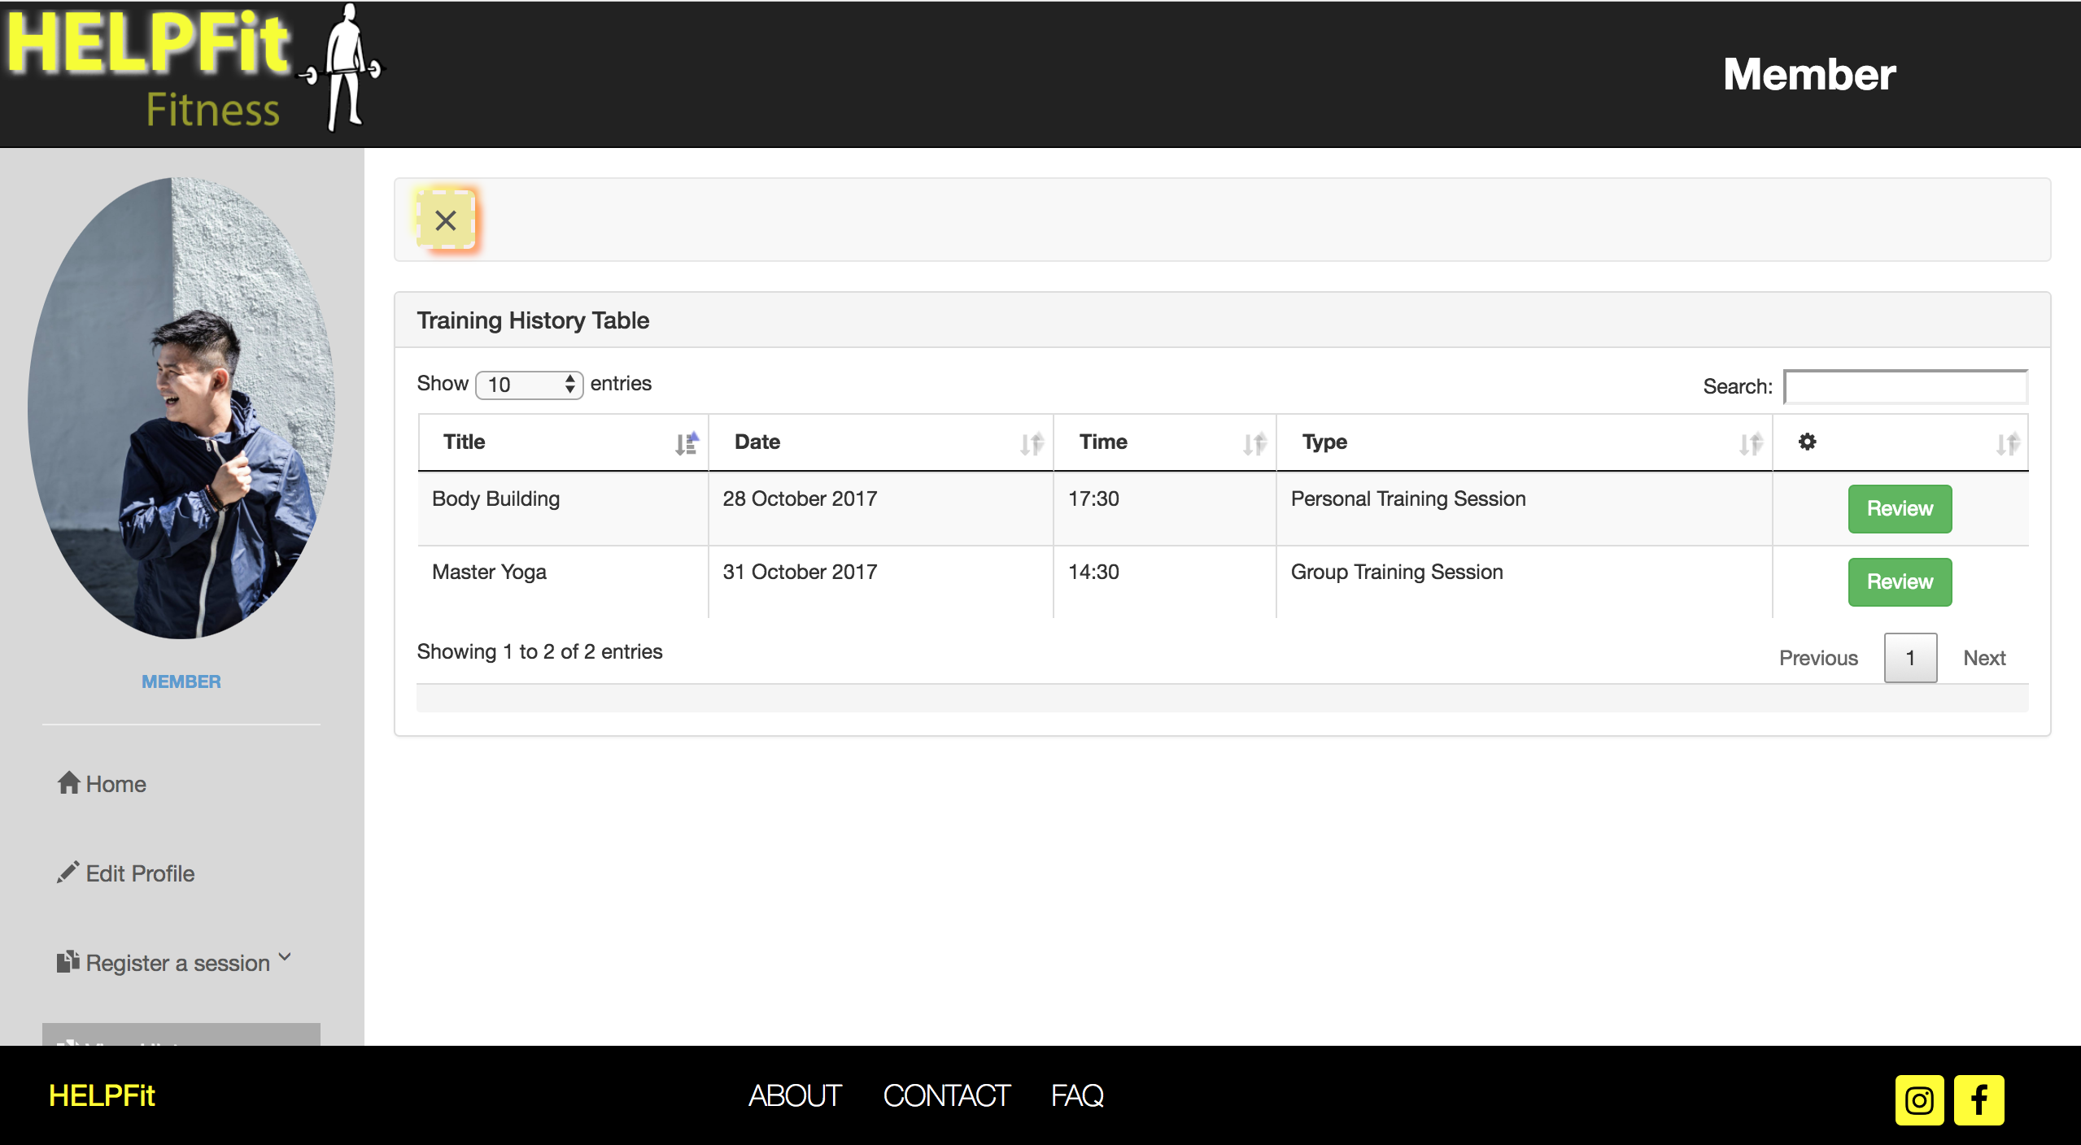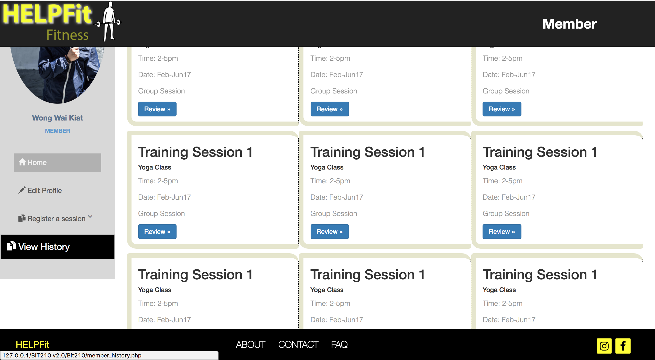Member Homepage Member Training Session History

Table

Test Case 3 -> Review Trainer

|  |  |
| --- | --- |
| Input | Click on the review button at the end of the column in the table to review |
| Expected Outcome | Review Personal Trainer Page is directed |
| Actual Outcome | Review Personal Trainer Page is directed |

Screen capture:

 Member Training Session History Page Review Personal Trainer Page

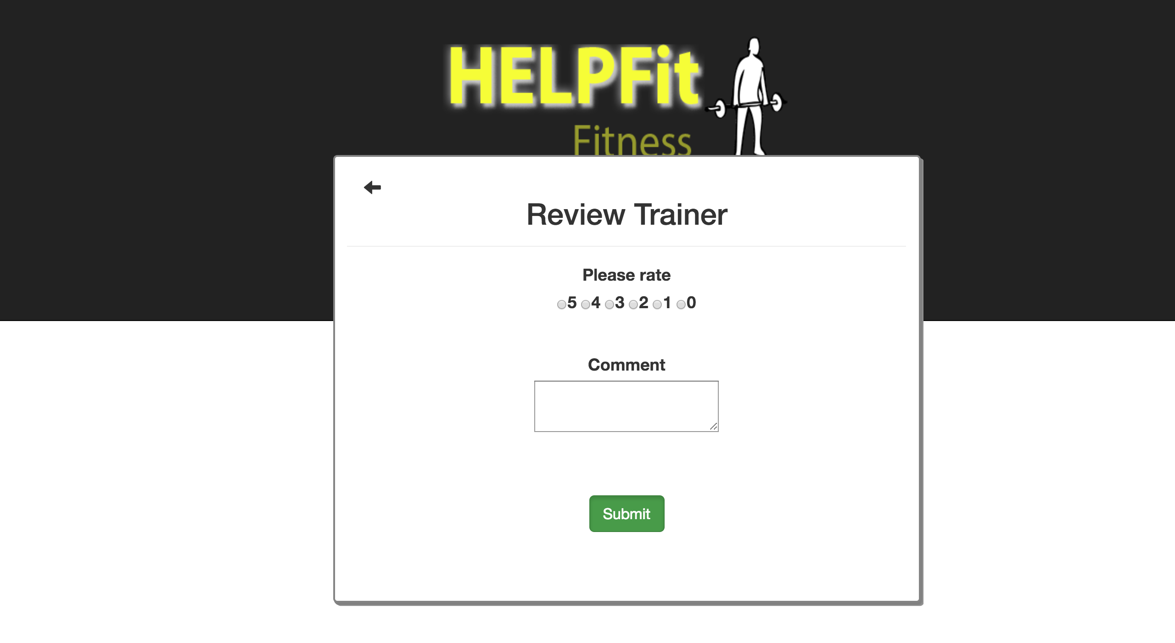Table

Test Case 4 -> Login as a Trainer

|  |  |
| --- | --- |
| Input | Username = “dan”  Password = “123456” |
| Expected Outcome | A successful message is shown and trainer homepage is directed |
| Actual Outcome | “Welcome!”, trainer homepage is directed |

Screen capture:

Login page Trainer homepage

Test Case 5 -> View History Personal Training Session Table

|  |  |
| --- | --- |
| Input | Click on the sidebar, View History tab and click on the sub tab, Personal Training Session |
| Expected Outcome | Personal Training Session History Page is directed |
| Actual Outcome | Personal Training Session History Page is directed |

Screen capture:

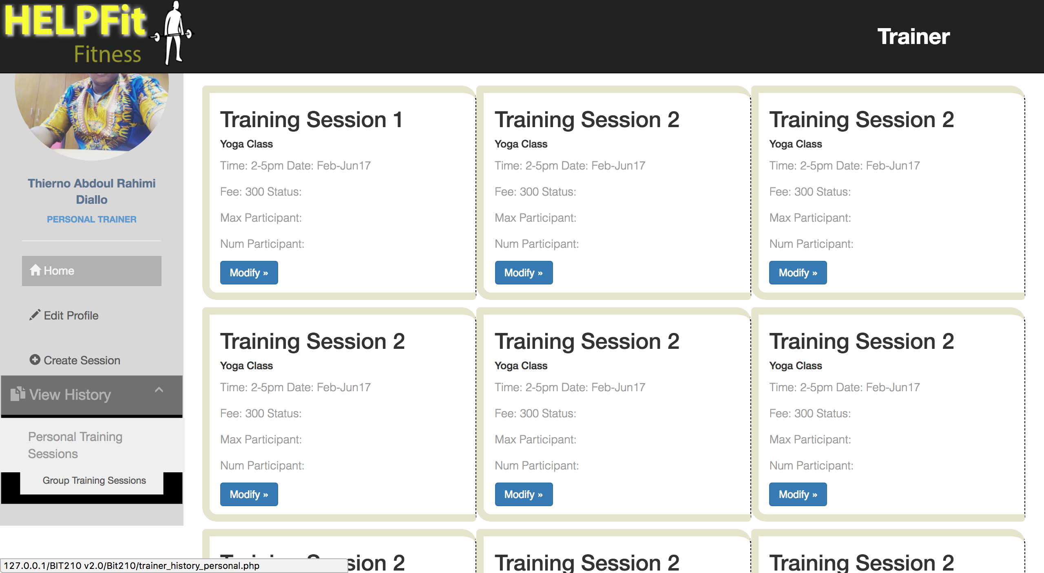Trainer Homepage Personal Training Session History Page

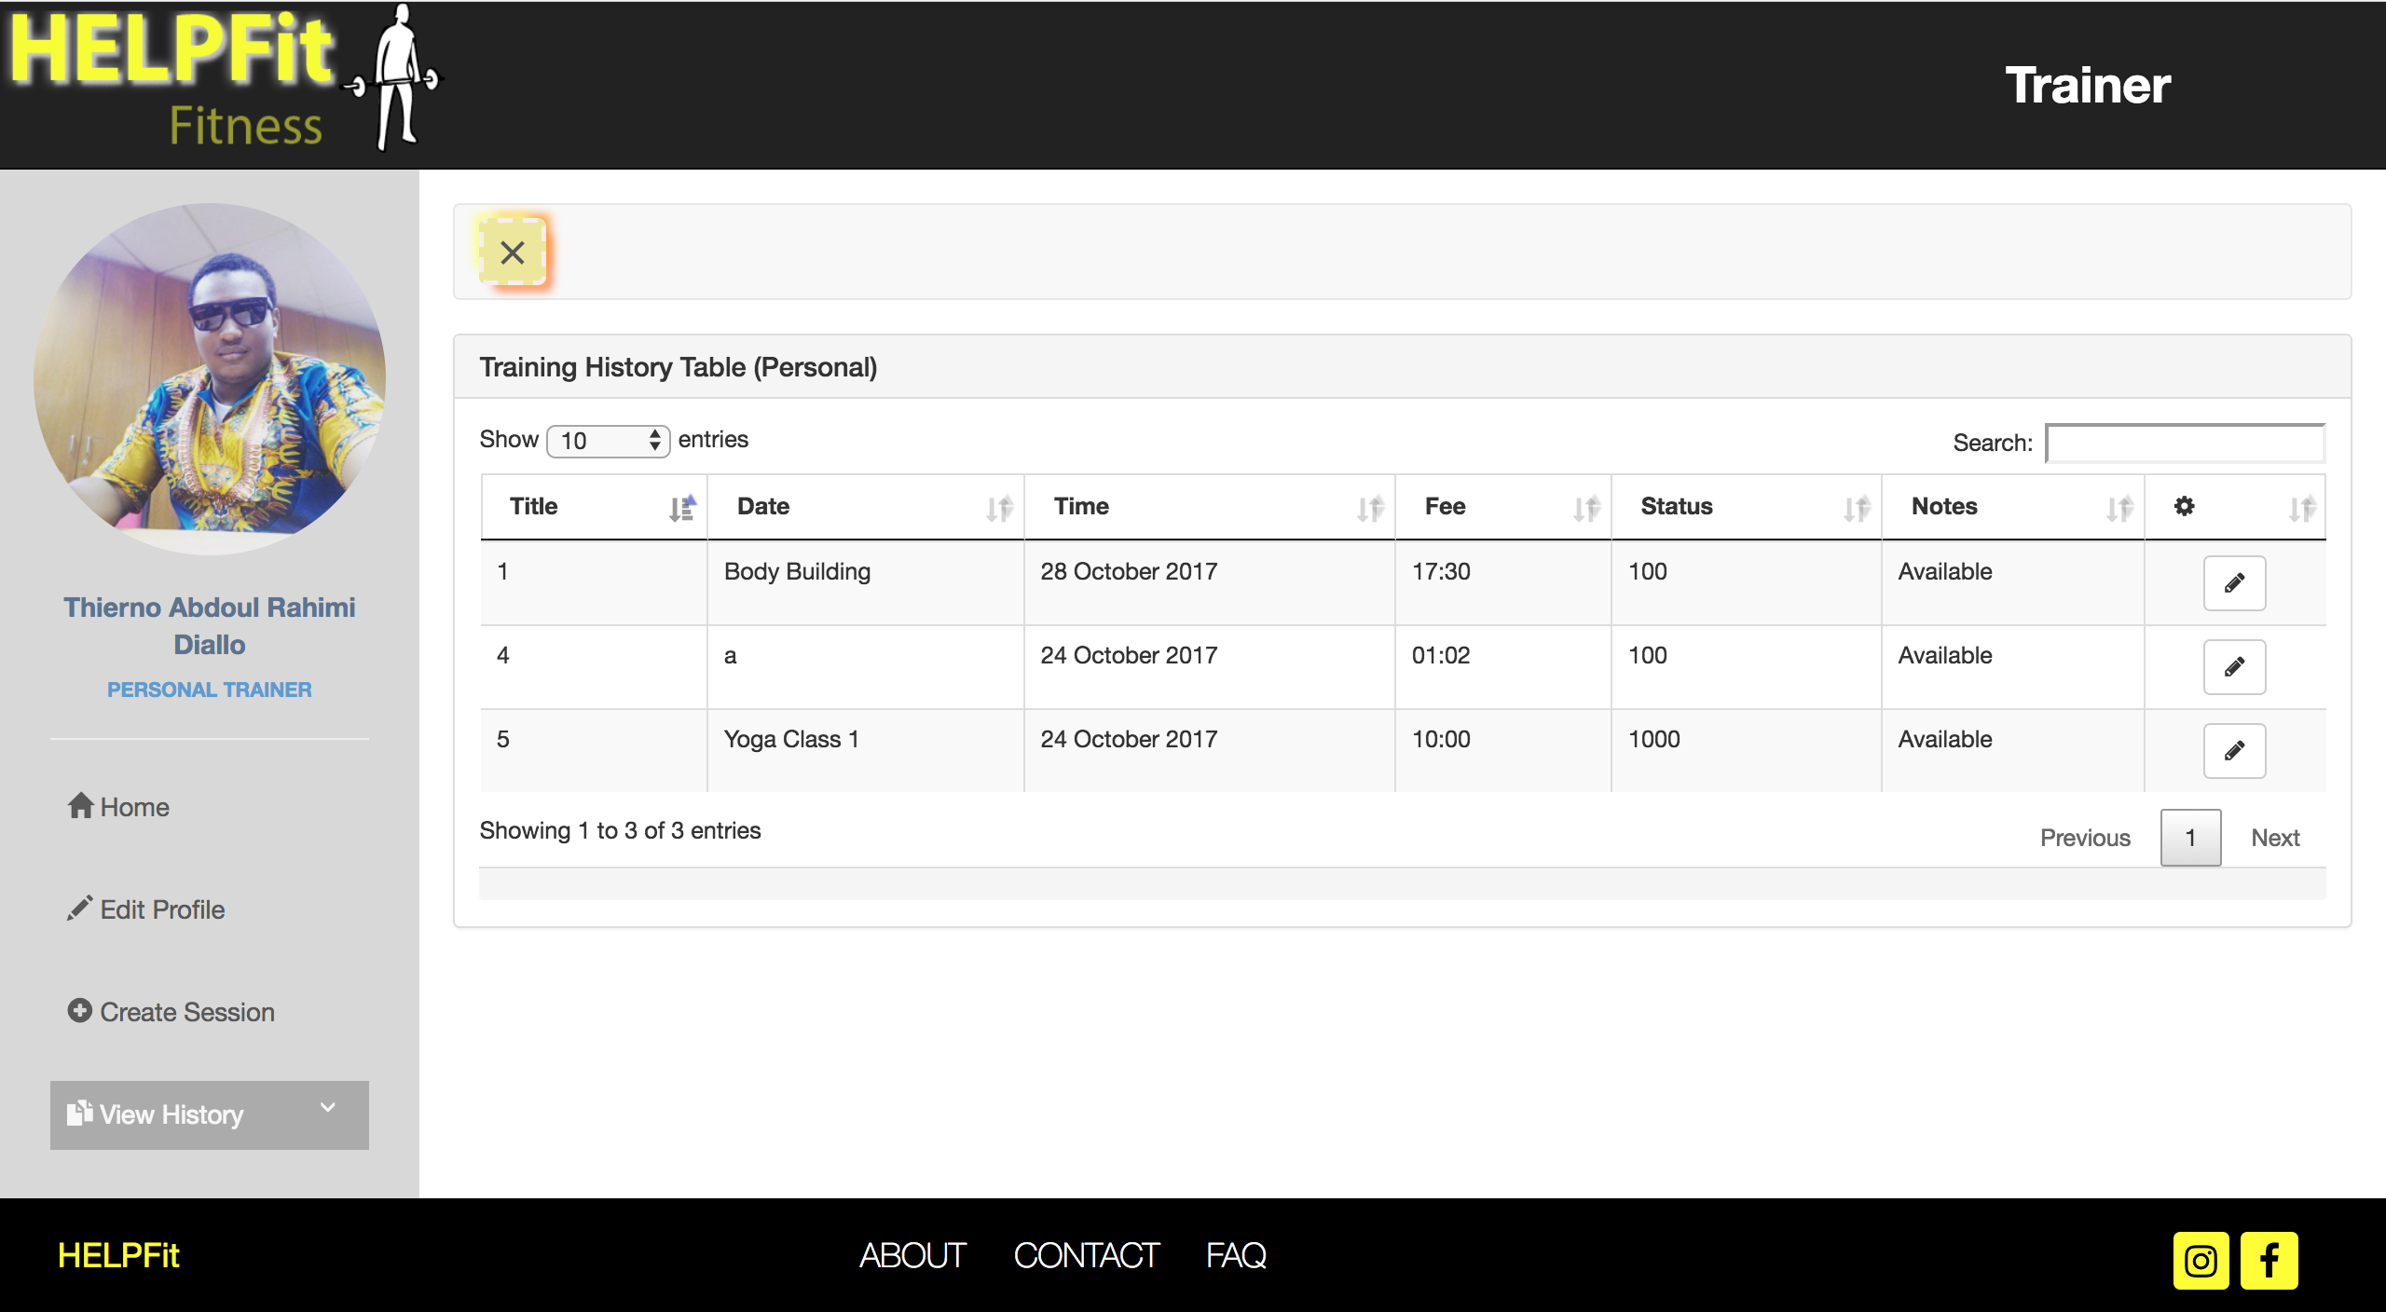

Test Case 6 -> Edit Personal Training Session

|  |  |
| --- | --- |
| Input | Click on the Glyphicon Edit button at the end of the column in the table |
| Expected Outcome | Edit Personal Trainer Session Page is directed |
| Actual Outcome | Edit Personal Trainer Session Page is directed |

Screen Capture:

Personal Training Session History Page Edit Personal Training Session Page

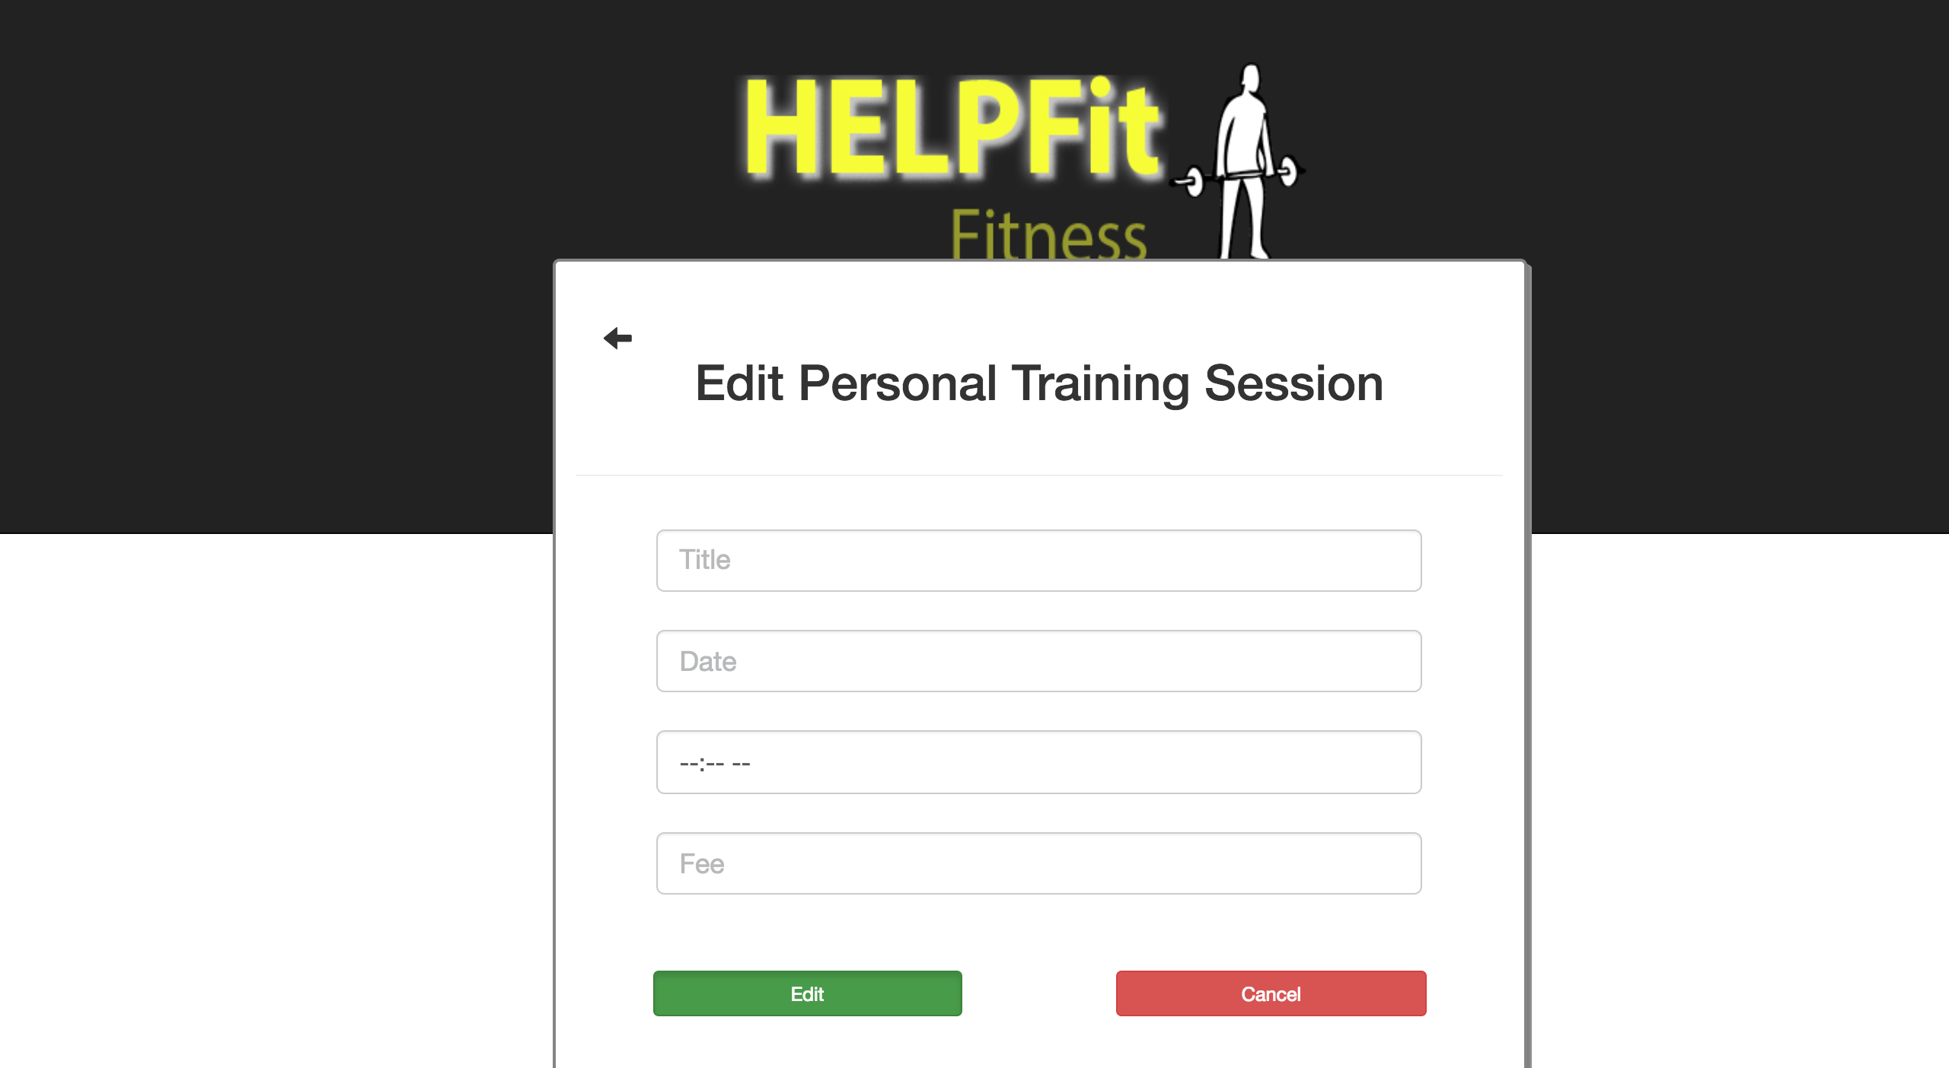

Test Case 7-> View Group Training Session History Page

|  |  |
| --- | --- |
| Input | Click on the sidebar, View History tab and click on the sub tab, Group Training Session |
| Expected Outcome | Group Training Session History Page is directed |
| Actual Outcome | Group Training Session History Page is directed |

Screen Capture:

Trainer Homepage Group Training Session History Pag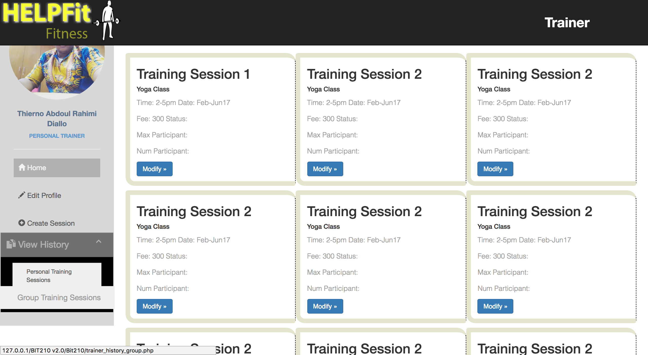e

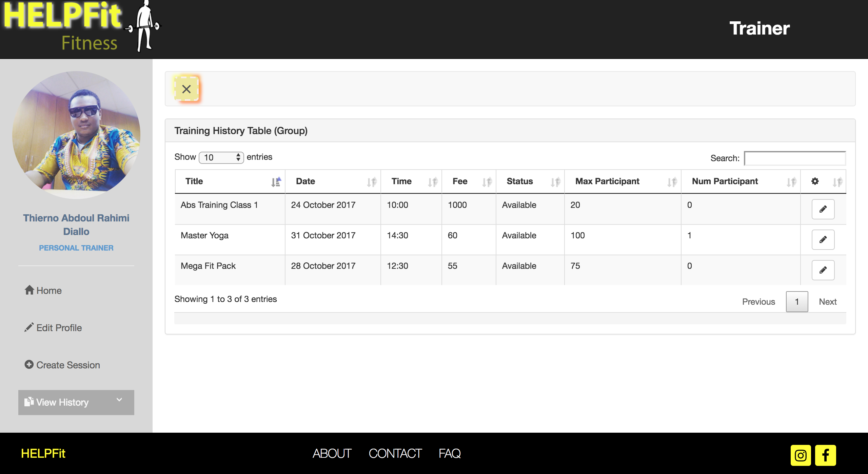

Test Case 8 -> Edit Group Training Session

|  |  |
| --- | --- |
| Input | Click on the Glyphicon Edit button at the end of the column in the table |
| Expected Outcome | Edit Group Trainer Session Page is directed |
| Actual Outcome | Edit Group Trainer Session Page is directed |

Screen Capture:

Group Training Session History Page Edit Group Training Session Page

